IMPACT AND ANALYSIS OF COVID19

IFT530: Enterprise Data Management Systems

Professor: Dr. Rob rucker

BY:

Chandana Kandari

Liaquath Hussain Shaik

Ramya Nagaraj

Table of Contents

PART-1 3

SUMMARY 3

Importance of Our Project 4

Questions Our Database Will Answer 5

Design Constraints and Cardinalities 6

Design Decisions 6

PART-2 7

ETL PRE-Processing 7

Conceptual Model 9

Physical Model 9

DATABASE 10

TABLE CREATION 10

DATA INSERTION 21

PART-3 26

SELECT QUERIES 26

CURSOR : 29

COMMON TABLE EXPRESSIONS 30

WINDOW FUNCTIONS -SQL 33

VIEWS 34

STORED PROCEDURE 37

TRIGGER 43

FUNCTIONS 45

PART-4 50

NOSQL 50

DATA VISUALIZATION 58

PART-5 60

Conclusion 60

PART-6 61

FUTURE WORK 61

REFERENCES 62

# PART-1

## SUMMARY

In December 2019 a number of novel coronavirus-infected pneumonia (NCIP) cases were recorded in a large metropolitan City in China, Wuhan, caused by infection with a novel coronavirus named SARS-CoV-21.Coronaviruses are a large family of viruses that are common in people and many different species of animals, including camels, cattle, cats, and bats. The outbreak subsequently spread to other cities in Hubei province and across China. Epidemiological data is needed during emerging epidemics to best monitor and anticipate spread of infection and evaluation of outbreak.

This project has been developed as a system for managing entire data on corona virus that has been spreading like fire all over the world. It enables data management which is an easy way to manage data records instead of doing everything manually. We have collected the real-time data from various sources and developed complete solution which maintains records of patients, country, hospital, Number of cases confirmed, Number of people died, Number of people recovered, amount of people getting affected by corona each year and the repercussion of it on country’s growth.

## Importance of Our Project

These data can be used to for investigate the epidemiological COVID-19 outbreak in China and elsewhere. We collected data on the following information: a) Key dates, which include the date of onset of disease, date of admission to hospital, date of confirmation of infection, and date of travel. b) Demographic information about the age and sex or patients/cases. c) Geographic information, at the highest resolution available i.e. Country Level. We used ETL tool Tableau document to reduce the risk of duplicate efforts or erroneous entries. We have normalized all our tables into 3NF form.

Our database is built taking into the factors like how long after infection people become contagious, when they start showing symptoms, and how long they are contagious after they recover. Our database provides a state-by-state breakdown along with the date starting from January 2020 to April 2020 of how total number of confirmed cases and the number of deaths and recovered in that state

We have Individual patient record and their travel history along with their symptoms and outcome and their current status. We have shown the number of hospitals in each country globally treating patients for coronavirus. We can even pull a record of individual person who is being treated in a particular hospital.

We have created Visualization on top of our Database to make most sense of our data and even predicted the impact of virus in future.

## Questions Our Database Will Answer

1. Number of active cases in the highest affected country?
2. Status of the patients who got admitted within the specified number of days after having symptoms.
3. Update the patient status as critical if they are in hospital active for more than provided input days
4. Show the Active cases as per specified country?
5. Show the records for number of cases and deaths per country?
6. Show records for COUNTRIES WHOSE GDP DECREASED?
7. Show records for COUNTRIES WHOSE GDP?
8. Retrieve all the records of the patients of USA, showing the patient id, hospital name, date of admission to the hospital, outcome (active / discharge/ died) and their travel history location.
9. Show the records and count of male, female and all the discharged patients in all the hospitals of all country
10. List All the unique symptoms observed in the covid -19 patients
11. List all the distinct places visited by COVID -19 patients as recorded in their travel records
12. Find the total cases, total deaths and total recovered patients of COVID-19 in each day of march month
13. Find the count of covid-19 patients recorded as dead in each hospital in different countries

## Design Constraints and Cardinalities

a)Primary Key and Foreign Key Relationships

|  |  |  |
| --- | --- | --- |
| **Entity** | **Primary Key** | **Foreign Key** |
| Covid-19 Census | Date | CountryName |
| Country | CountryName |  |
| Patient | PaientID |  |
| Travel Record |  | PatientID, HospitalID, CountryName |
| Hospital | HospitalID | CountryName |
|  |  |  |

b)Relationship between different entities

|  |  |  |  |
| --- | --- | --- | --- |
| **S.No** | **Entity1** | **Entity2** | **Relationship Degree** |
| 1 | Patient | Hospital | 1:M |
| 2 | Patient | Country | M:1 |
| 3 | Patient | Travel Record | 1:M |
| 4 | Hospital | Country | M:1 |
| 5 | Country | Covid-19 Census | 1:M |

## Design Decisions

1. Many Patients can be admitted into one Hospital whereas one Patient is treated in one Hospital which establishes M:1 relationship between Patient and Hospital.
2. Many Patients can be from one Country whereas one Patient belongs to one Country which establishes M:1 relationship between Patient and Country.
3. One Patient can have many Travel Records whereas one Travel Record belongs to one Patient which establishes 1:M relationship between Patient and Travel Record.
4. Many Hospitals can be in one Country whereas one Hospital is located in one Country which establishes M:1 relationship between Hospital and Country.
5. One Country can have many Covid19 Patients health status whereas many Covid19 Patients health status belongs to one Country which establishes 1:M relationship between Country and Health Census.

# PART-2

## ETL PRE-Processing

We have used Tableau Prep-Builder to create a workflow to clean our data as in removing the duplicates and consolidating the data records into rows and columns in which our database tables are designed

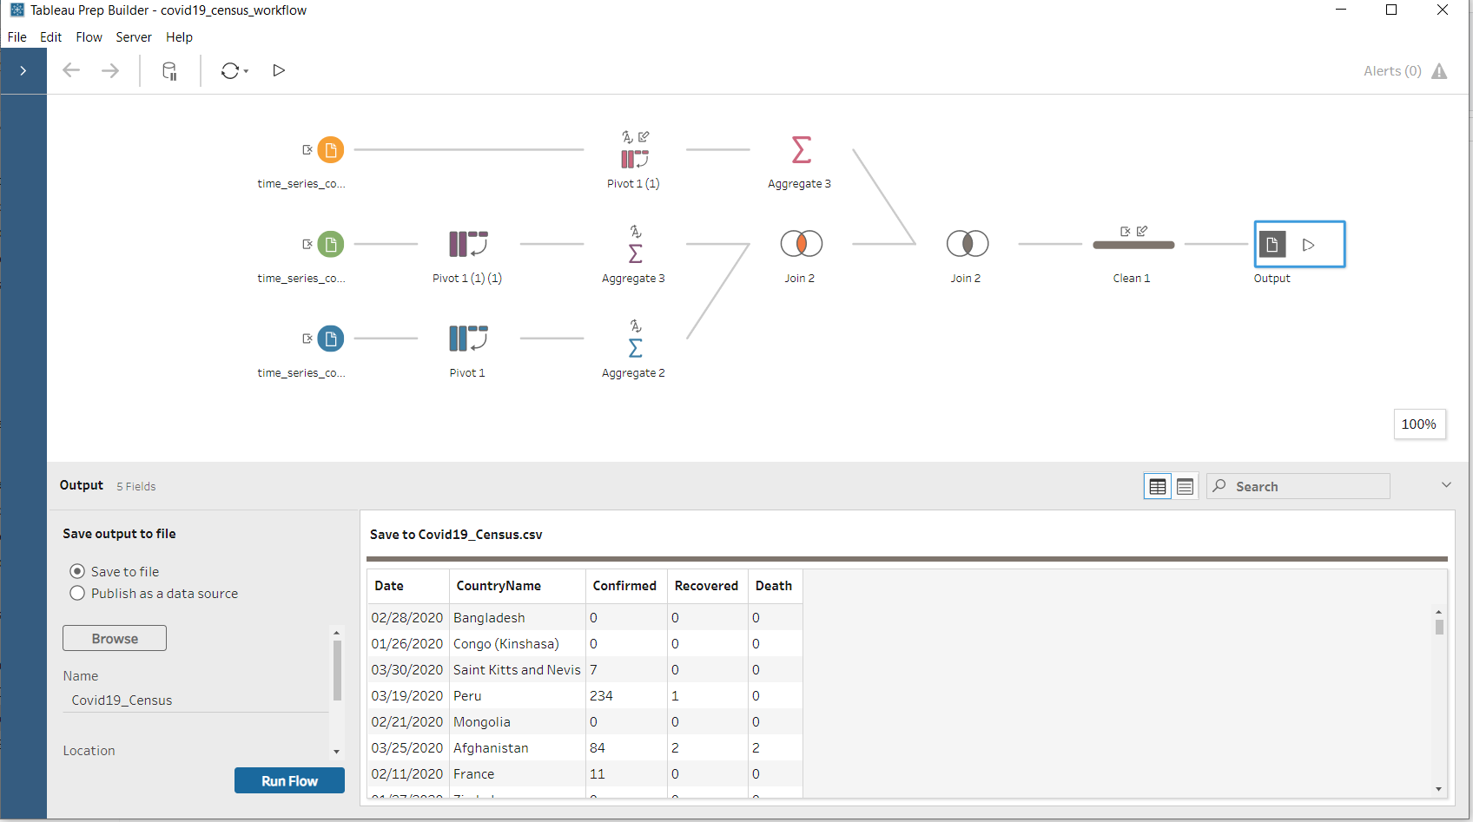

In the above workflow we had data which had date as column headers and the value of it was total numbers of cases confirmed and recovered and death in three separate files respectively. We have pivoted rows into columns and using country name and date as composite primary key as well as grouping by those two columns we have aggregated the sum of total cases and death and recovered and joined all three data files and sent them to the destination DB.

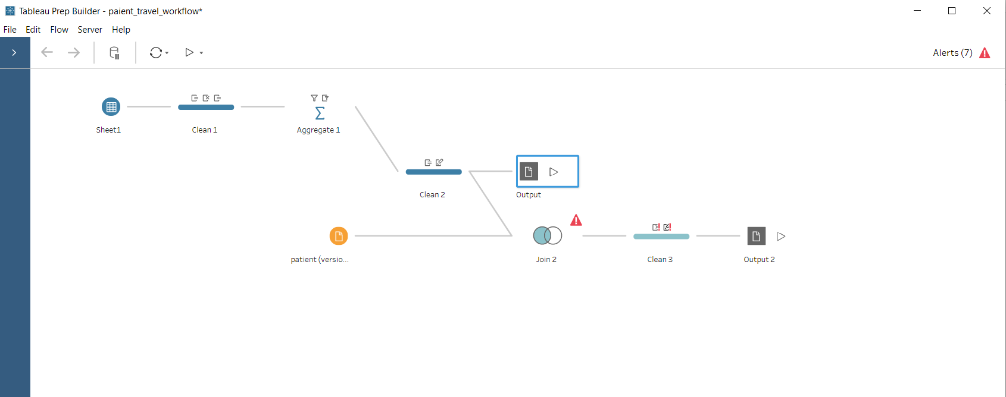

In the above workflow we are creating a travelID for each location and joinng with patient table by travel_location.

## Conceptual Model

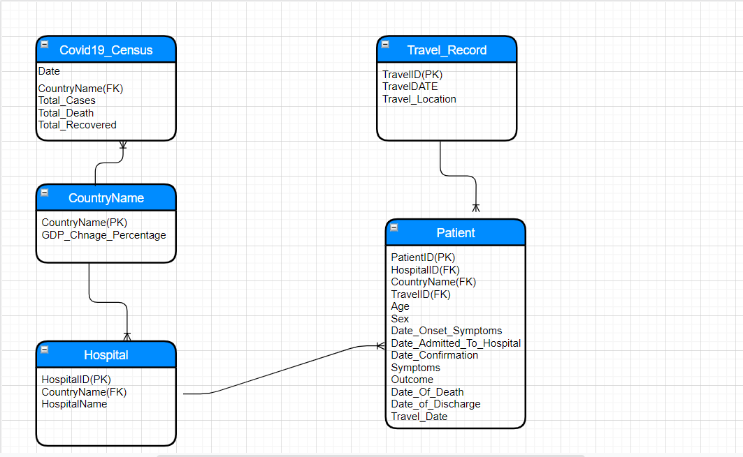

## Physical Model

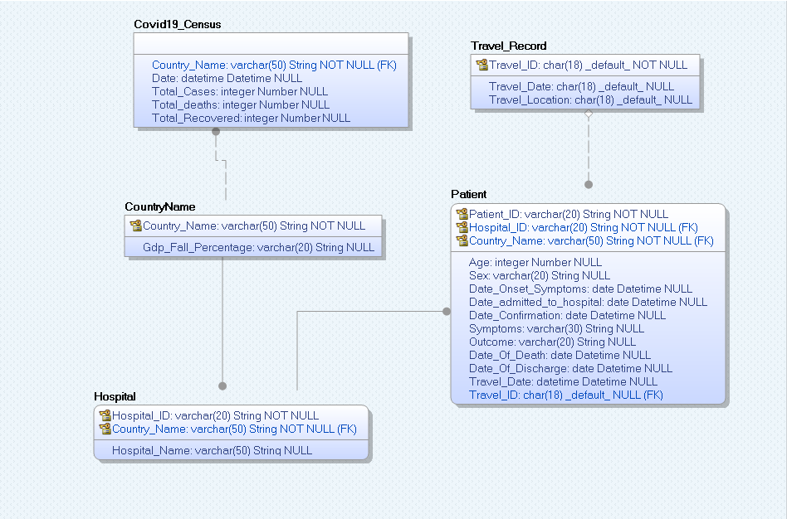

## DATABASE

IF DB_ID('Covid19') IS NOT NULL

BEGIN

DROP DATABASE Covid19

END

## TABLE CREATION

use Covid19

go

CREATE TABLE [CountryName]

(

[Country_Name] varchar(50) NOT NULL ,

[Gdp_Fall_Percentage] varchar(20) NULL

)

Go

ALTER TABLE [CountryName]

ADD CONSTRAINT [XPKCountryName] PRIMARY KEY CLUSTERED ([Country_Name] ASC)

go

CREATE TABLE [Covid19_Census]

(

[Date] datetime NOT NULL ,

[Country_Name] varchar(50) NOT NULL ,

[Total_Cases] integer NULL ,

[Total_deaths] integer NULL ,

[Total_Recovered] integer NULL

--primary key([Date] ,[Country_Name] )

)

go

ALTER TABLE [Covid19_Census]

ADD CONSTRAINT [XPKCovid19_Census] PRIMARY KEY CLUSTERED ([Date] ASC,[Country_Name] ASC)

Go

CREATE TABLE [Hospital]

(

[Hospital_ID] varchar(20) NOT NULL ,

[Hospital_Name] varchar(100) NULL ,

[Country_Name] varchar(50) NOT NULL

)

go

ALTER TABLE [Hospital]

ADD CONSTRAINT [XPKHospital] PRIMARY KEY CLUSTERED ([Hospital_ID] ASC,[Country_Name] ASC)

go

CREATE TABLE [Patient]

(

[Patient_ID] varchar(20) NOT NULL ,

[Age] integer NULL ,

[Sex] varchar(20) NULL ,

[Date_Onset_Symptoms] date NULL ,

[Date_admitted_to_hospital] date NULL ,

[Date_Confirmation] date NULL ,

[Symptoms] varchar(100) NULL ,

[Outcome] varchar(20) NULL ,

[Date_Of_Death] date NULL ,

[Date_Of_Discharge] date NULL ,

[Hospital_ID] varchar(20) NOT NULL ,

[Country_Name] varchar(50) NOT NULL ,

[Travel_Date] datetime NULL ,

[Travel_ID] char(18) NULL

)

go

ALTER TABLE [Patient]

ADD CONSTRAINT [XPKPatient] PRIMARY KEY CLUSTERED ([Patient_ID] ASC,[Hospital_ID] ASC,[Country_Name] ASC)

Go

CREATE TABLE [Travel_Record]

(

[Travel_ID] char(18) NOT NULL ,

--[Travel_Date] char(18) NULL ,

[Travel_Location] varchar(100) NULL

)

go

ALTER TABLE [Travel_Record]

ADD CONSTRAINT [XPKTravel_Record] PRIMARY KEY CLUSTERED ([Travel_ID] ASC)

go

ALTER TABLE [Covid19_Census]

ADD CONSTRAINT [R_1] FOREIGN KEY ([Country_Name]) REFERENCES [CountryName]([Country_Name])

ON DELETE NO ACTION

ON UPDATE NO ACTION

go

ALTER TABLE [Hospital]

ADD CONSTRAINT [R_2] FOREIGN KEY ([Country_Name]) REFERENCES [CountryName]([Country_Name])

ON DELETE NO ACTION

ON UPDATE NO ACTION

go

ALTER TABLE [Patient]

ADD CONSTRAINT [R_3] FOREIGN KEY ([Hospital_ID],[Country_Name]) REFERENCES [Hospital]([Hospital_ID],[Country_Name])

ON DELETE NO ACTION

ON UPDATE NO ACTION

go

ALTER TABLE [Patient]

ADD CONSTRAINT [R_6] FOREIGN KEY ([Travel_ID]) REFERENCES [Travel_Record]([Travel_ID])

ON DELETE NO ACTION

ON UPDATE NO ACTION

go

CREATE TRIGGER tD_CountryName ON CountryName FOR DELETE AS

BEGIN

DECLARE @errno int,

@severity int,

@state int,

@errmsg varchar(255)

IF EXISTS (

SELECT * FROM deleted,Hospital

WHERE

Hospital.Country_Name = deleted.Country_Name

)

BEGIN

SELECT @errno = 30001,

@errmsg = 'Cannot delete CountryName because Hospital exists.'

GOTO error

END

IF EXISTS (

SELECT * FROM deleted,Covid19_Census

WHERE

Covid19_Census.Country_Name = deleted.Country_Name

)

BEGIN

SELECT @errno = 30001,

@errmsg = 'Cannot delete CountryName because Covid19_Census exists.'

GOTO error

END

RETURN

error:

RAISERROR (@errmsg,

@severity,

@state)

rollback transaction

END

go

CREATE TRIGGER tU_CountryName ON CountryName FOR UPDATE AS

BEGIN

DECLARE @numrows int,

@nullcnt int,

@validcnt int,

@insCountry_Name varchar(50),

@errno int,

@severity int,

@state int,

@errmsg varchar(255)

SELECT @numrows = @@rowcount

IF

UPDATE(Country_Name)

BEGIN

IF EXISTS (

SELECT * FROM deleted,Hospital

WHERE

Hospital.Country_Name = deleted.Country_Name

)

BEGIN

SELECT @errno = 30005,

@errmsg = 'Cannot update CountryName because Hospital exists.'

GOTO error

END

END

IF

UPDATE(Country_Name)

BEGIN

IF EXISTS (

SELECT * FROM deleted,Covid19_Census

WHERE

Covid19_Census.Country_Name = deleted.Country_Name

)

BEGIN

SELECT @errno = 30005,

@errmsg = 'Cannot update CountryName because Covid19_Census exists.'

GOTO error

END

END

RETURN

error:

RAISERROR (@errmsg,

@severity,

@state)

rollback transaction

END

go

CREATE TRIGGER tD_Covid19_Census ON Covid19_Census FOR DELETE AS

BEGIN

DECLARE @errno int,

@severity int,

@state int,

@errmsg varchar(255)

IF EXISTS (SELECT * FROM deleted,CountryName

WHERE

deleted.Country_Name = CountryName.Country_Name AND

NOT EXISTS (

SELECT * FROM Covid19_Census

WHERE

Covid19_Census.Country_Name = CountryName.Country_Name

)

)

BEGIN

SELECT @errno = 30010,

@errmsg = 'Cannot delete last Covid19_Census because CountryName exists.'

GOTO error

END

RETURN

error:

RAISERROR (@errmsg,

@severity,

@state)

rollback transaction

END

go

CREATE TRIGGER tU_Covid19_Census ON Covid19_Census FOR UPDATE AS

BEGIN

DECLARE @numrows int,

@nullcnt int,

@validcnt int,

@insDate datetime,

@insCountry_Name varchar(50),

@errno int,

@severity int,

@state int,

@errmsg varchar(255)

SELECT @numrows = @@rowcount

IF

UPDATE(Country_Name)

BEGIN

SELECT @nullcnt = 0

SELECT @validcnt = count(*)

FROM inserted,CountryName

WHERE

inserted.Country_Name = CountryName.Country_Name

IF @validcnt + @nullcnt != @numrows

BEGIN

SELECT @errno = 30007,

@errmsg = 'Cannot update Covid19_Census because CountryName does not exist.'

GOTO error

END

END

RETURN

error:

RAISERROR (@errmsg,

@severity,

@state)

rollback transaction

END

go

CREATE TRIGGER tD_Hospital ON Hospital FOR DELETE AS

BEGIN

DECLARE @errno int,

@severity int,

@state int,

@errmsg varchar(255)

IF EXISTS (

SELECT * FROM deleted,Patient

WHERE

Patient.Hospital_ID = deleted.Hospital_ID AND

Patient.Country_Name = deleted.Country_Name

)

BEGIN

SELECT @errno = 30001,

@errmsg = 'Cannot delete Hospital because Patient exists.'

GOTO error

END

IF EXISTS (SELECT * FROM deleted,CountryName

WHERE

deleted.Country_Name = CountryName.Country_Name AND

NOT EXISTS (

SELECT * FROM Hospital

WHERE

Hospital.Country_Name = CountryName.Country_Name

)

)

BEGIN

SELECT @errno = 30010,

@errmsg = 'Cannot delete last Hospital because CountryName exists.'

GOTO error

END

RETURN

error:

RAISERROR (@errmsg,

@severity,

@state)

rollback transaction

END

go

CREATE TRIGGER tU_Hospital ON Hospital FOR UPDATE AS

BEGIN

DECLARE @numrows int,

@nullcnt int,

@validcnt int,

@insHospital_ID varchar(20),

@insCountry_Name varchar(50),

@errno int,

@severity int,

@state int,

@errmsg varchar(255)

SELECT @numrows = @@rowcount

IF

UPDATE(Hospital_ID) OR

UPDATE(Country_Name)

BEGIN

IF EXISTS (

SELECT * FROM deleted,Patient

WHERE

Patient.Hospital_ID = deleted.Hospital_ID AND

Patient.Country_Name = deleted.Country_Name

)

BEGIN

SELECT @errno = 30005,

@errmsg = 'Cannot update Hospital because Patient exists.'

GOTO error

END

END

IF

UPDATE(Country_Name)

BEGIN

SELECT @nullcnt = 0

SELECT @validcnt = count(*)

FROM inserted,CountryName

WHERE

inserted.Country_Name = CountryName.Country_Name

IF @validcnt + @nullcnt != @numrows

BEGIN

SELECT @errno = 30007,

@errmsg = 'Cannot update Hospital because CountryName does not exist.'

GOTO error

END

END

RETURN

error:

RAISERROR (@errmsg,

@severity,

@state)

rollback transaction

END

go

CREATE TRIGGER tD_Patient ON Patient FOR DELETE AS

BEGIN

DECLARE @errno int,

@severity int,

@state int,

@errmsg varchar(255)

IF EXISTS (SELECT * FROM deleted,Travel_Record

WHERE

deleted.Travel_ID = Travel_Record.Travel_ID AND

NOT EXISTS (

SELECT * FROM Patient

WHERE

Patient.Travel_ID = Travel_Record.Travel_ID

)

)

BEGIN

SELECT @errno = 30010,

@errmsg = 'Cannot delete last Patient because Travel_Record exists.'

GOTO error

END

IF EXISTS (SELECT * FROM deleted,Hospital

WHERE

deleted.Hospital_ID = Hospital.Hospital_ID AND

deleted.Country_Name = Hospital.Country_Name AND

NOT EXISTS (

SELECT * FROM Patient

WHERE

Patient.Hospital_ID = Hospital.Hospital_ID AND

Patient.Country_Name = Hospital.Country_Name

)

)

BEGIN

SELECT @errno = 30010,

@errmsg = 'Cannot delete last Patient because Hospital exists.'

GOTO error

END

RETURN

error:

RAISERROR (@errmsg,

@severity,

@state)

rollback transaction

END

go

CREATE TRIGGER tU_Patient ON Patient FOR UPDATE AS

BEGIN

DECLARE @numrows int,

@nullcnt int,

@validcnt int,

@insPatient_ID varchar(20),

@insHospital_ID varchar(20),

@insCountry_Name varchar(50),

@errno int,

@severity int,

@state int,

@errmsg varchar(255)

SELECT @numrows = @@rowcount

IF

UPDATE(Travel_ID)

BEGIN

SELECT @nullcnt = 0

SELECT @validcnt = count(*)

FROM inserted,Travel_Record

WHERE

inserted.Travel_ID = Travel_Record.Travel_ID

select @nullcnt = count(*) from inserted where

inserted.Travel_ID IS NULL

IF @validcnt + @nullcnt != @numrows

BEGIN

SELECT @errno = 30007,

@errmsg = 'Cannot update Patient because Travel_Record does not exist.'

GOTO error

END

END

IF

UPDATE(Hospital_ID) OR

UPDATE(Country_Name)

BEGIN

SELECT @nullcnt = 0

SELECT @validcnt = count(*)

FROM inserted,Hospital

WHERE

inserted.Hospital_ID = Hospital.Hospital_ID and

inserted.Country_Name = Hospital.Country_Name

IF @validcnt + @nullcnt != @numrows

BEGIN

SELECT @errno = 30007,

@errmsg = 'Cannot update Patient because Hospital does not exist.'

GOTO error

END

END

RETURN

error:

RAISERROR (@errmsg,

@severity,

@state)

rollback transaction

END

go

CREATE TRIGGER tD_Travel_Record ON Travel_Record FOR DELETE AS

BEGIN

DECLARE @errno int,

@severity int,

@state int,

@errmsg varchar(255)

IF EXISTS (

SELECT * FROM deleted,Patient

WHERE

Patient.Travel_ID = deleted.Travel_ID

)

BEGIN

SELECT @errno = 30001,

@errmsg = 'Cannot delete Travel_Record because Patient exists.'

GOTO error

END

RETURN

error:

RAISERROR (@errmsg,

@severity,

@state)

rollback transaction

END

go

CREATE TRIGGER tU_Travel_Record ON Travel_Record FOR UPDATE AS

BEGIN

DECLARE @numrows int,

@nullcnt int,

@validcnt int,

@insTravel_ID char(18),

@errno int,

@severity int,

@state int,

@errmsg varchar(255)

SELECT @numrows = @@rowcount

IF

UPDATE(Travel_ID)

BEGIN

IF EXISTS (

SELECT * FROM deleted,Patient

WHERE

Patient.Travel_ID = deleted.Travel_ID

)

BEGIN

SELECT @errno = 30005,

@errmsg = 'Cannot update Travel_Record because Patient exists.'

GOTO error

END

END

RETURN

error:

RAISERROR (@errmsg,

@severity,

@state)

rollback transaction

END

go

## DATA INSERTION

1)COVID19_CENSUS

INSERT [dbo].[Covid19_Census] ([Date], [Total_Cases], [Total_Recovered], [Total_Deaths], [Country_Name]) VALUES (CAST(N'2020-02-11T00:00:00.0000000' AS DateTime2), N'11', N'0', N'0', N'France')

INSERT [dbo].[Covid19_Census] ([Date], [Total_Cases], [Total_Recovered], [Total_Deaths], [Country_Name]) VALUES (CAST(N'2020-02-01T00:00:00.0000000' AS DateTime2), N'8', N'0', N'0', N'Malaysia')

INSERT [dbo].[Covid19_Census] ([Date], [Total_Cases], [Total_Recovered], [Total_Deaths], [Country_Name]) VALUES (CAST(N'2020-03-02T00:00:00.0000000' AS DateTime2), N'0', N'0', N'0', N'Bolivia')

INSERT [dbo].[Covid19_Census] ([Date], [Total_Cases], [Total_Recovered], [Total_Deaths], [Country_Name]) VALUES (CAST(N'2020-02-15T00:00:00.0000000' AS DateTime2), N'3', N'1', N'1', N'Philippines')

INSERT [dbo].[Covid19_Census] ([Date], [Total_Cases], [Total_Recovered], [Total_Deaths], [Country_Name]) VALUES (CAST(N'2020-01-31T00:00:00.0000000' AS DateTime2), N'9802', N'214', N'213', N'China')

INSERT [dbo].[Covid19_Census] ([Date], [Total_Cases], [Total_Recovered], [Total_Deaths], [Country_Name]) VALUES (CAST(N'2020-02-07T00:00:00.0000000' AS DateTime2), N'0', N'0', N'0', N'Romania')

INSERT [dbo].[Covid19_Census] ([Date], [Total_Cases], [Total_Recovered], [Total_Deaths], [Country_Name]) VALUES (CAST(N'2020-01-29T00:00:00.0000000' AS DateTime2), N'7', N'1', N'0', N'Japan')

INSERT [dbo].[Covid19_Census] ([Date], [Total_Cases], [Total_Recovered], [Total_Deaths], [Country_Name]) VALUES (CAST(N'2020-03-31T00:00:00.0000000' AS DateTime2), N'2766', N'537', N'43', N'Malaysia')

INSERT [dbo].[Covid19_Census] ([Date], [Total_Cases], [Total_Recovered], [Total_Deaths], [Country_Name]) VALUES (CAST(N'2020-03-05T00:00:00.0000000' AS DateTime2), N'50', N'22', N'0', N'Malaysia')

INSERT [dbo].[Covid19_Census] ([Date], [Total_Cases], [Total_Recovered], [Total_Deaths], [Country_Name]) VALUES (CAST(N'2020-03-13T00:00:00.0000000' AS DateTime2), N'47', N'16', N'0', N'Vietnam')

INSERT [dbo].[Covid19_Census] ([Date], [Total_Cases], [Total_Recovered], [Total_Deaths], [Country_Name]) VALUES (CAST(N'2020-03-08T00:00:00.0000000' AS DateTime2), N'50', N'31', N'1', N'Thailand')

INSERT [dbo].[Covid19_Census] ([Date], [Total_Cases], [Total_Recovered], [Total_Deaths], [Country_Name]) VALUES (CAST(N'2020-03-03T00:00:00.0000000' AS DateTime2), N'293', N'43', N'6', N'Japan')

INSERT [dbo].[Covid19_Census] ([Date], [Total_Cases], [Total_Recovered], [Total_Deaths], [Country_Name]) VALUES (CAST(N'2020-02-15T00:00:00.0000000' AS DateTime2), N'12', N'4', N'1', N'France')

INSERT [dbo].[Covid19_Census] ([Date], [Total_Cases], [Total_Recovered], [Total_Deaths], [Country_Name]) VALUES (CAST(N'2020-03-31T00:00:00.0000000' AS DateTime2), N'1953', N'424', N'56', N'Japan')

INSERT [dbo].[Covid19_Census] ([Date], [Total_Cases], [Total_Recovered], [Total_Deaths], [Country_Name]) VALUES (CAST(N'2020-02-03T00:00:00.0000000' AS DateTime2), N'0', N'0', N'0', N'Bhutan')

INSERT [dbo].[Covid19_Census] ([Date], [Total_Cases], [Total_Recovered], [Total_Deaths], [Country_Name]) VALUES (CAST(N'2020-04-04T00:00:00.0000000' AS DateTime2), N'5', N'2', N'0', N'Bhutan')

INSERT [dbo].[Covid19_Census] ([Date], [Total_Cases], [Total_Recovered], [Total_Deaths], [Country_Name]) VALUES (CAST(N'2020-02-24T00:00:00.0000000' AS DateTime2), N'0', N'0', N'0', N'Namibia')

2)COUNTRY NAME

USE [covid19]

GO

INSERT [dbo].[CountryName] ([Country_Name], [Gdp_Fall_Percentage]) VALUES (N'Bhutan', N'7%')

INSERT [dbo].[CountryName] ([Country_Name], [Gdp_Fall_Percentage]) VALUES (N'Bolivia', N'-3.50%')

INSERT [dbo].[CountryName] ([Country_Name], [Gdp_Fall_Percentage]) VALUES (N'Brazil', N'-6.00%')

INSERT [dbo].[CountryName] ([Country_Name], [Gdp_Fall_Percentage]) VALUES (N'Cambodia', N'6.60%')

INSERT [dbo].[CountryName] ([Country_Name], [Gdp_Fall_Percentage]) VALUES (N'China', N'4.90%')

INSERT [dbo].[CountryName] ([Country_Name], [Gdp_Fall_Percentage]) VALUES (N'France', N'-8.80%')

INSERT [dbo].[CountryName] ([Country_Name], [Gdp_Fall_Percentage]) VALUES (N'Italy', N'-8.00%')

INSERT [dbo].[CountryName] ([Country_Name], [Gdp_Fall_Percentage]) VALUES (N'Japan', N'-6.00%')

INSERT [dbo].[CountryName] ([Country_Name], [Gdp_Fall_Percentage]) VALUES (N'Malaysia', N'-2.70%')

INSERT [dbo].[CountryName] ([Country_Name], [Gdp_Fall_Percentage]) VALUES (N'Namibia', N'-3.80%')

INSERT [dbo].[CountryName] ([Country_Name], [Gdp_Fall_Percentage]) VALUES (N'Nepal', N'6.20%')

INSERT [dbo].[CountryName] ([Country_Name], [Gdp_Fall_Percentage]) VALUES (N'Philippines', N'0.70%')

INSERT [dbo].[CountryName] ([Country_Name], [Gdp_Fall_Percentage]) VALUES (N'Romania', N'-6.80%')

INSERT [dbo].[CountryName] ([Country_Name], [Gdp_Fall_Percentage]) VALUES (N'Singapore', N'-6.90%')

INSERT [dbo].[CountryName] ([Country_Name], [Gdp_Fall_Percentage]) VALUES (N'South Korea', N'-1.70%')

INSERT [dbo].[CountryName] ([Country_Name], [Gdp_Fall_Percentage]) VALUES (N'Switzerland', N'-8.70%')

INSERT [dbo].[CountryName] ([Country_Name], [Gdp_Fall_Percentage]) VALUES (N'Thailand', N'-2.80%')

INSERT [dbo].[CountryName] ([Country_Name], [Gdp_Fall_Percentage]) VALUES (N'United States', N'-16.50%')

INSERT [dbo].[CountryName] ([Country_Name], [Gdp_Fall_Percentage]) VALUES (N'Vietnam', N'3.60%')

3)HOSPITAL

USE [covid19]

GO

INSERT [dbo].[Hospital] ([Hospital_ID], [Hospital_Name], [Country_Name]) VALUES (N'BO49', N'Hospital Pucarani', N'Bolivia')

INSERT [dbo].[Hospital] ([Hospital_ID], [Hospital_Name], [Country_Name]) VALUES (N'BU1001', N'Jigme Dorji Wangchuck National Referral Hospital', N'Bhutan')

INSERT [dbo].[Hospital] ([Hospital_ID], [Hospital_Name], [Country_Name]) VALUES (N'BU1002', N'Rangjung Basic Health Unit', N'Bhutan')

INSERT [dbo].[Hospital] ([Hospital_ID], [Hospital_Name], [Country_Name]) VALUES (N'BZ202', N'Hospital Vital Brasil', N'Brazil')

INSERT [dbo].[Hospital] ([Hospital_ID], [Hospital_Name], [Country_Name]) VALUES (N'BZ212', N'Hospital Samaritano', N'Brazil')

INSERT [dbo].[Hospital] ([Hospital_ID], [Hospital_Name], [Country_Name]) VALUES (N'BZ222', N'Hospital Daher Lago Sul', N'Brazil')

INSERT [dbo].[Hospital] ([Hospital_ID], [Hospital_Name], [Country_Name]) VALUES (N'BZ232', N'Puesto de Salud', N'Brazil')

INSERT [dbo].[Hospital] ([Hospital_ID], [Hospital_Name], [Country_Name]) VALUES (N'C0521', N'Calmette Hospital', N'Cambodia')

INSERT [dbo].[Hospital] ([Hospital_ID], [Hospital_Name], [Country_Name]) VALUES (N'CH21', N'People''s Hospital of Guangxi Zhuang Autonomous Region', N'China')

INSERT [dbo].[Hospital] ([Hospital_ID], [Hospital_Name], [Country_Name]) VALUES (N'CH22', N'Haikou City People''s Hospital', N'China')

INSERT [dbo].[Hospital] ([Hospital_ID], [Hospital_Name], [Country_Name]) VALUES (N'CH23', N'West China Medical Center of Sichuan University', N'China')

INSERT [dbo].[Hospital] ([Hospital_ID], [Hospital_Name], [Country_Name]) VALUES (N'CH24', N'Beijing Buwai Hospital', N'China')

INSERT [dbo].[Hospital] ([Hospital_ID], [Hospital_Name], [Country_Name]) VALUES (N'CO421', N'Royal Angkor International Hospital', N'Cambodia')

INSERT [dbo].[Hospital] ([Hospital_ID], [Hospital_Name], [Country_Name]) VALUES (N'FR456', N'American Hospital of Paris', N'France')

INSERT [dbo].[Hospital] ([Hospital_ID], [Hospital_Name], [Country_Name]) VALUES (N'FR765', N'Central Hospital', N'France')

INSERT [dbo].[Hospital] ([Hospital_ID], [Hospital_Name], [Country_Name]) VALUES (N'IT599', N'Campolongo Hospital', N'Italy')

INSERT [dbo].[Hospital] ([Hospital_ID], [Hospital_Name], [Country_Name]) VALUES (N'JP345', N'Chubu Rosai Hospital�', N'Japan')

INSERT [dbo].[Hospital] ([Hospital_ID], [Hospital_Name], [Country_Name]) VALUES (N'JP787', N'Japan Community Health care Organization Chukyo Hospital', N'Japan')

INSERT [dbo].[Hospital] ([Hospital_ID], [Hospital_Name], [Country_Name]) VALUES (N'JP789', N'Nagoya University Hospital', N'Japan')

INSERT [dbo].[Hospital] ([Hospital_ID], [Hospital_Name], [Country_Name]) VALUES (N'JP998', N'National Hospital Organization Nagoya Medical Center�', N'Japan')

4)TRAVEL RECORD

USE [covid19]

GO

INSERT [dbo].[Travel_Record] ([Travel_ID], [Travel_Location]) VALUES (1, N'Yokohama')

INSERT [dbo].[Travel_Record] ([Travel_ID], [Travel_Location]) VALUES (2, N'Yinchuan')

INSERT [dbo].[Travel_Record] ([Travel_ID], [Travel_Location]) VALUES (3, N'Yichang City, Hubei')

INSERT [dbo].[Travel_Record] ([Travel_ID], [Travel_Location]) VALUES (4, N'Xiaogan City, Huber province')

INSERT [dbo].[Travel_Record] ([Travel_ID], [Travel_Location]) VALUES (5, N'Xiaogan')

INSERT [dbo].[Travel_Record] ([Travel_ID], [Travel_Location]) VALUES (6, N'Xianyang City')

INSERT [dbo].[Travel_Record] ([Travel_ID], [Travel_Location]) VALUES (7, N'Xiangyang, Hubei')

INSERT [dbo].[Travel_Record] ([Travel_ID], [Travel_Location]) VALUES (8, N'Xiangtan')

INSERT [dbo].[Travel_Record] ([Travel_ID], [Travel_Location]) VALUES (9, N'Wuhan; Nanning')

INSERT [dbo].[Travel_Record] ([Travel_ID], [Travel_Location]) VALUES (10, N'Wuhan, China')

INSERT [dbo].[Travel_Record] ([Travel_ID], [Travel_Location]) VALUES (11, N'Wuhan via Xi''an')

INSERT [dbo].[Travel_Record] ([Travel_ID], [Travel_Location]) VALUES (12, N'Wuhan via Shanghai')

INSERT [dbo].[Travel_Record] ([Travel_ID], [Travel_Location]) VALUES (13, N'Wuhan via Qingdao')

INSERT [dbo].[Travel_Record] ([Travel_ID], [Travel_Location]) VALUES (14, N'Wuhan to Xuanwei')

INSERT [dbo].[Travel_Record] ([Travel_ID], [Travel_Location]) VALUES (15, N'Wuhan City, Hubei Province')

INSERT [dbo].[Travel_Record] ([Travel_ID], [Travel_Location]) VALUES (16, N'Wuhan - Hefei - Lujiang')

INSERT [dbo].[Travel_Record] ([Travel_ID], [Travel_Location]) VALUES (17, N'Wuhan')

INSERT [dbo].[Travel_Record] ([Travel_ID], [Travel_Location]) VALUES (18, N'Went to Thailand; had dinner with firedns prior to trip')

INSERT [dbo].[Travel_Record] ([Travel_ID], [Travel_Location]) VALUES (19, N'Vietnam')

INSERT [dbo].[Travel_Record] ([Travel_ID], [Travel_Location]) VALUES (20, N'Thailand')

INSERT [dbo].[Travel_Record] ([Travel_ID], [Travel_Location]) VALUES (21, N'Taizhou, Jiangsu')

INSERT [dbo].[Travel_Record] ([Travel_ID], [Travel_Location]) VALUES (22, N'Shiyan City, Hubei; Qingyuan County, Guangdong')

5)PATIENT

USE [covid19]

GO

INSERT [dbo].[Patient] ([Patient_ID], [age], [sex], [date_onset_symptoms], [date_admitted_to_hospital], [date_confirmation], [symptoms], [outcome], [date_of_Death], [date_of_discharge], [Hospital_ID], [Country_Name], [travel_date], [Travel_ID]) VALUES (N'000-1-100', 65, N'female', CAST(N'2020-03-04' AS Date), CAST(N'2020-03-04' AS Date), CAST(N'2020-02-05' AS Date), N'fever, sore throat, cough, shortness of breath', N'Active', NULL, NULL, N'BU1001', N'Bhutan', CAST(N'2020-02-21' AS Date), 42)

INSERT [dbo].[Patient] ([Patient_ID], [age], [sex], [date_onset_symptoms], [date_admitted_to_hospital], [date_confirmation], [symptoms], [outcome], [date_of_Death], [date_of_discharge], [Hospital_ID], [Country_Name], [travel_date], [Travel_ID]) VALUES (N'000-1-101', 36, N'male', CAST(N'2020-03-04' AS Date), CAST(N'2020-03-04' AS Date), CAST(N'2020-02-05' AS Date), N'fever, sore throat, cough, shortness of breath', N'Active', NULL, NULL, N'BU1001', N'Bhutan', CAST(N'2020-02-21' AS Date), 42)

INSERT [dbo].[Patient] ([Patient_ID], [age], [sex], [date_onset_symptoms], [date_admitted_to_hospital], [date_confirmation], [symptoms], [outcome], [date_of_Death], [date_of_discharge], [Hospital_ID], [Country_Name], [travel_date], [Travel_ID]) VALUES (N'000-1-1017', 44, N'male', CAST(N'2020-03-08' AS Date), CAST(N'2020-03-08' AS Date), CAST(N'2020-03-10' AS Date), N'fever, general weakness', N'Active', NULL, NULL, N'BO49', N'Bolivia', CAST(N'2020-07-03' AS Date), 50)

INSERT [dbo].[Patient] ([Patient_ID], [age], [sex], [date_onset_symptoms], [date_admitted_to_hospital], [date_confirmation], [symptoms], [outcome], [date_of_Death], [date_of_discharge], [Hospital_ID], [Country_Name], [travel_date], [Travel_ID]) VALUES (N'000-1-103', 63, N'female', CAST(N'2020-02-24' AS Date), CAST(N'2020-02-25' AS Date), CAST(N'2020-02-26' AS Date), N'fever, cough, running nose', N'discharged', NULL, CAST(N'2020-04-05' AS Date), N'BZ202', N'Brazil', CAST(N'2020-09-02' AS Date), 36)

INSERT [dbo].[Patient] ([Patient_ID], [age], [sex], [date_onset_symptoms], [date_admitted_to_hospital], [date_confirmation], [symptoms], [outcome], [date_of_Death], [date_of_discharge], [Hospital_ID], [Country_Name], [travel_date], [Travel_ID]) VALUES (N'000-1-104', 37, N'female', CAST(N'2020-02-27' AS Date), CAST(N'2020-02-28' AS Date), CAST(N'2020-02-28' AS Date), N'fever, cough, sore throat, mialgia, headache', N'discharged', NULL, CAST(N'2020-04-05' AS Date), N'BZ212', N'Brazil', CAST(N'2020-02-27' AS Date), 36)

INSERT [dbo].[Patient] ([Patient_ID], [age], [sex], [date_onset_symptoms], [date_admitted_to_hospital], [date_confirmation], [symptoms], [outcome], [date_of_Death], [date_of_discharge], [Hospital_ID], [Country_Name], [travel_date], [Travel_ID]) VALUES (N'000-1-10648', 60, N'male', CAST(N'2020-03-05' AS Date), CAST(N'2020-03-05' AS Date), CAST(N'2020-03-07' AS Date), N'fever, cough, nasal congestion', N'Active', NULL, NULL, N'BZ222', N'Brazil', CAST(N'2020-04-03' AS Date), 36)

INSERT [dbo].[Patient] ([Patient_ID], [age], [sex], [date_onset_symptoms], [date_admitted_to_hospital], [date_confirmation], [symptoms], [outcome], [date_of_Death], [date_of_discharge], [Hospital_ID], [Country_Name], [travel_date], [Travel_ID]) VALUES (N'000-1-10675', 45, N'male', CAST(N'2020-03-05' AS Date), CAST(N'2020-03-05' AS Date), CAST(N'2020-03-08' AS Date), N'Rhinorrhea, pain and unwellness', N'Active', NULL, NULL, N'BZ232', N'Brazil', CAST(N'2020-02-03' AS Date), 36)

INSERT [dbo].[Patient] ([Patient_ID], [age], [sex], [date_onset_symptoms], [date_admitted_to_hospital], [date_confirmation], [symptoms], [outcome], [date_of_Death], [date_of_discharge], [Hospital_ID], [Country_Name], [travel_date], [Travel_ID]) VALUES (N'000-1-1084', 68, N'female', CAST(N'2020-02-29' AS Date), CAST(N'2020-02-29' AS Date), CAST(N'2020-03-12' AS Date), N'fever, cough, coriza, sore throath, headache, general weakness', N'Active', NULL, NULL, N'BZ202', N'Brazil', CAST(N'2020-01-21' AS Date), 36)

INSERT [dbo].[Patient] ([Patient_ID], [age], [sex], [date_onset_symptoms], [date_admitted_to_hospital], [date_confirmation], [symptoms], [outcome], [date_of_Death], [date_of_discharge], [Hospital_ID], [Country_Name], [travel_date], [Travel_ID]) VALUES (N'000-1-1085', 64, N'male', CAST(N'2020-03-09' AS Date), CAST(N'2020-03-09' AS Date), CAST(N'2020-03-12' AS Date), N'fever, respiratory problems (lungs)', N'Active', NULL, NULL, N'BZ212', N'Brazil', NULL, 27)

INSERT [dbo].[Patient] ([Patient_ID], [age], [sex], [date_onset_symptoms], [date_admitted_to_hospital], [date_confirmation], [symptoms], [outcome], [date_of_Death], [date_of_discharge], [Hospital_ID], [Country_Name], [travel_date], [Travel_ID]) VALUES (N'000-1-1087', 60, N'male', CAST(N'2020-02-29' AS Date), CAST(N'2020-03-04' AS Date), CAST(N'2020-03-12' AS Date), N'fever, cough and sore throath', N'Active', NULL, NULL, N'BZ222', N'Brazil', CAST(N'2020-02-20' AS Date), 37)

INSERT [dbo].[Patient] ([Patient_ID], [age], [sex], [date_onset_symptoms], [date_admitted_to_hospital], [date_confirmation], [symptoms], [outcome], [date_of_Death], [date_of_discharge], [Hospital_ID], [Country_Name], [travel_date], [Travel_ID]) VALUES (N'000-1-10911', 45, N'male', CAST(N'2020-03-08' AS Date), CAST(N'2020-03-10' AS Date), CAST(N'2020-03-13' AS Date), N'fever, body ache, sore throat, headache', N'Active', NULL, NULL, N'BZ232', N'Brazil', CAST(N'2020-06-03' AS Date), 47)

# PART-3

## SELECT QUERIES

1. Retrieve all the records of the patients of USA , showing the patient id, hospital name, date of admission to the hospital, outcome (active / discharge/ died) and their travel history location.

select [Patient_ID],[Date_admitted_to_hospital],[Outcome],[Hospital_Name],Travel_Location

from [dbo].[Hospital] join [dbo].[Patient] on [dbo].[Patient].Hospital_ID = [dbo].[Hospital].Hospital_ID

join [dbo].[Travel_Record] on [dbo].[Travel_Record].Travel_ID = [dbo].[Patient].Travel_ID

where [dbo].[Patient].Country_Name = 'United States'

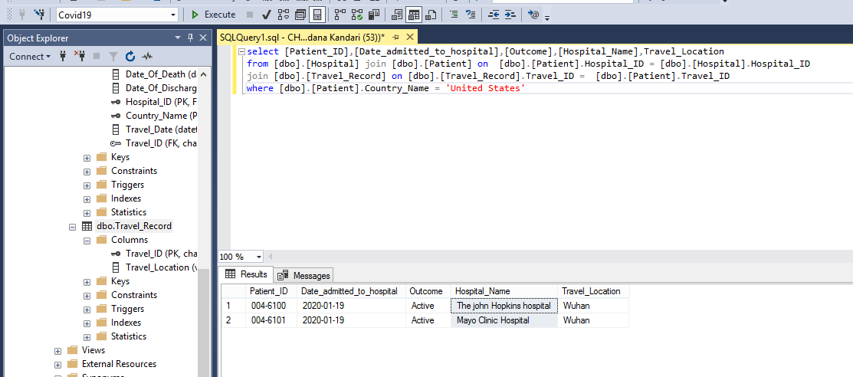

1. Count of all the active patients in all the hospitals of China country grouped by hospital name.

select COUNT([Patient_ID]) as 'No. of Active Patients',[Hospital_Name]

from [dbo].[Patient] join [dbo].[Hospital] on [dbo].[Patient].Hospital_ID = [dbo].[Hospital].Hospital_ID

where [dbo].[Patient].Country_Name = 'China' and [dbo].[Patient].Outcome = 'Active'

Group By [Hospital_Name]

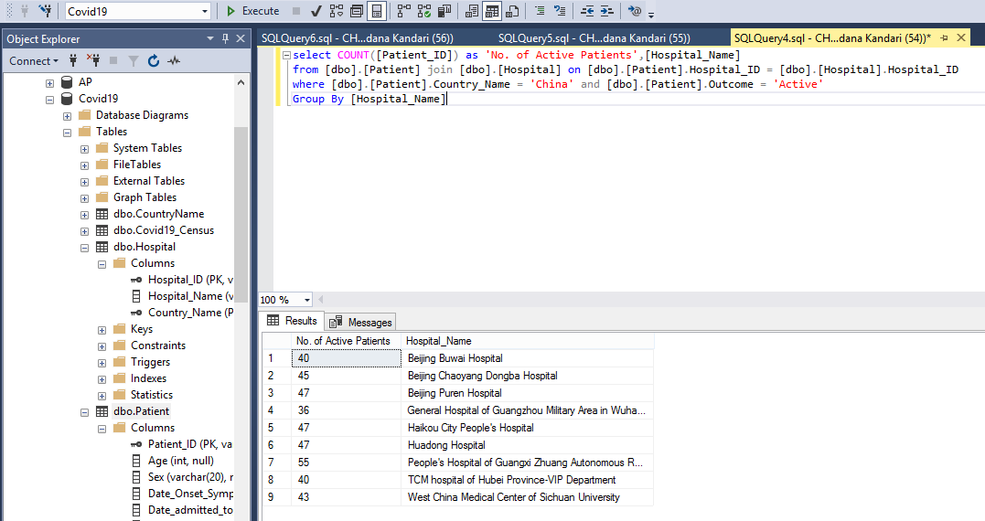

1. Records and count of male, female and all the discharged patients in all the hospitals of all country

select COUNT([Patient_ID]) as 'Total discharged patients',COUNT(CASE WHEN [Sex]= 'male' THEN 1 END) as 'No. of Discharged male Patients',

COUNT(CASE WHEN [Sex]= 'female' THEN 1 END) as 'No. of Discharged female Patients',[Hospital_Name],[dbo].[Patient].[Country_Name]

from [dbo].[Patient] join [dbo].[Hospital] on [dbo].[Patient].Hospital_ID = [dbo].[Hospital].Hospital_ID

where [dbo].[Patient].Outcome = 'discharged'

Group By [dbo].[Patient].[Country_Name],[Hospital_Name] ORDER BY [dbo].[Patient].[Country_Name]

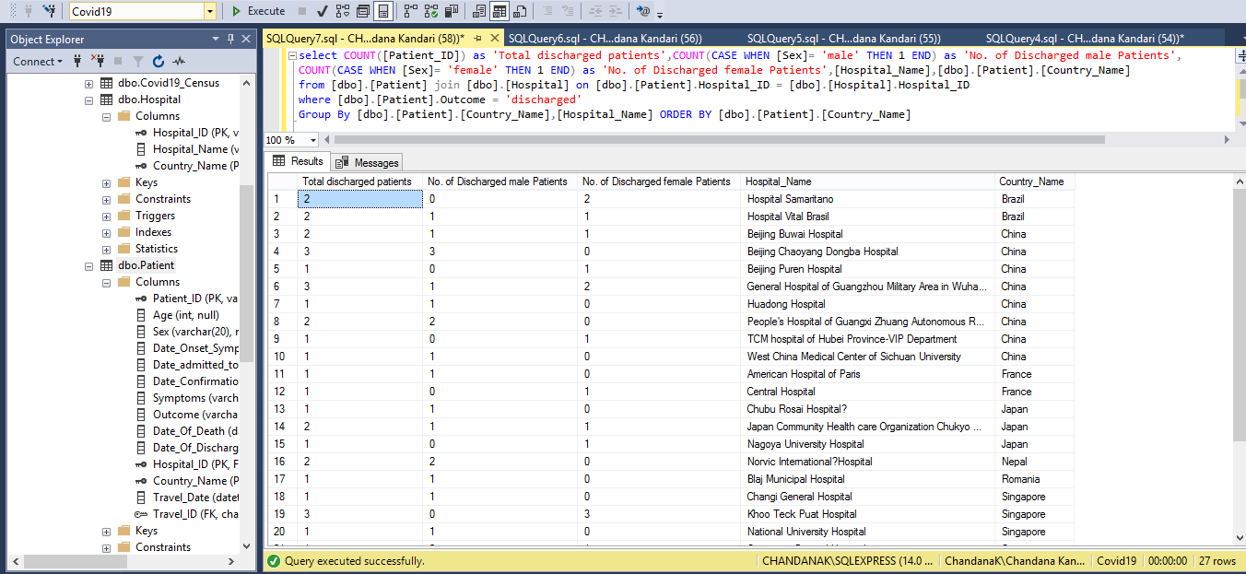

1. List All the unique symptoms observed in the covid -19 patients

SELECT value [Symptoms] INTO TEMP_T from [dbo].[Patient] CROSS APPLY STRING_SPLIT([Symptoms], ',');

select distinct [Symptoms] from TEMP_T

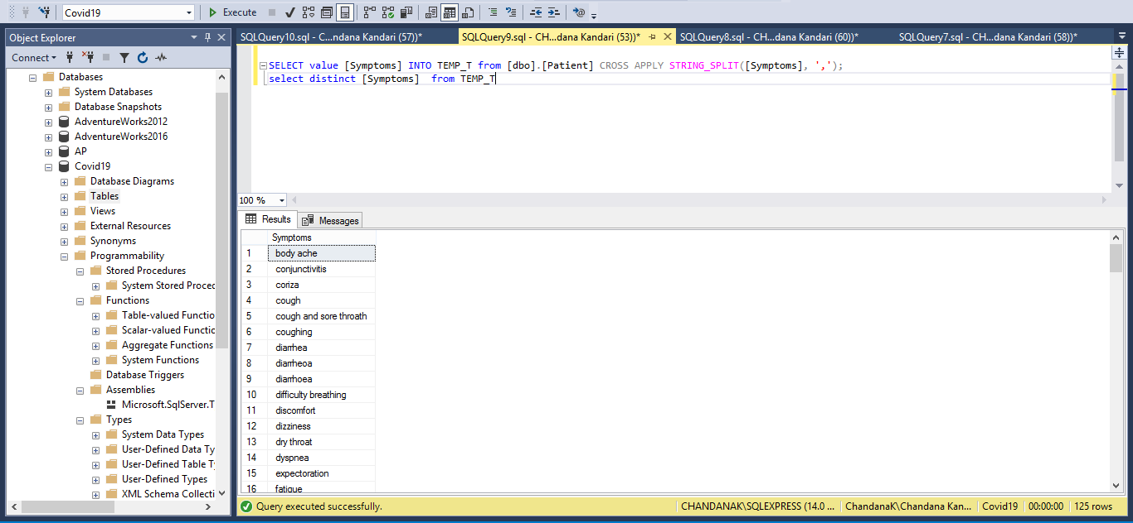

1. Find the total cases, total deaths and total recovered patients of COVID-19 date wise

SELECT DISTINCT [Date],SUM([Total_Cases]) as [Total_Cases],SUM([Total_deaths]) as Total_Deaths,SUM([Total_Recovered]) as Total_Recovered

FROM [Covid19].[dbo].[Covid19_Census] group by [Date] order by [Date]

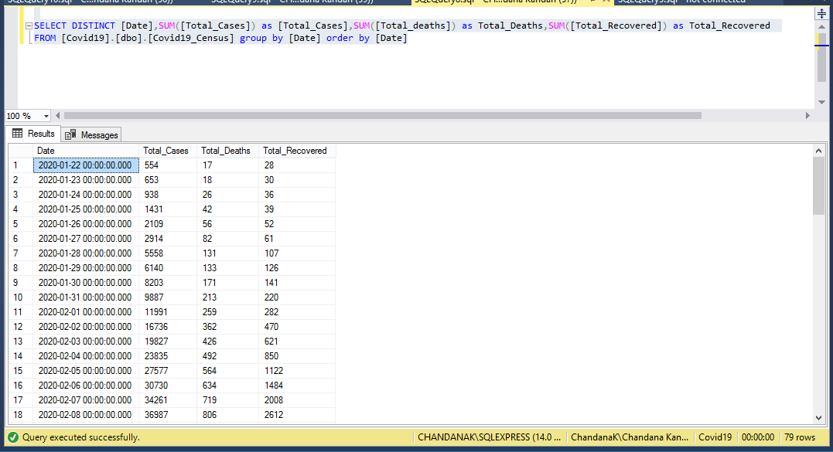

## CURSOR :

1. List all the distinct places visited by COVID -19 patients as recorded in their travel records

DECLARE

@Travel_Location VARCHAR(MAX);

DECLARE cursor_LOC CURSOR

FOR SELECT DISTINCT * FROM (SELECT value [Travel_Location]

FROM [dbo].[Travel_Record]

CROSS APPLY STRING_SPLIT([Travel_Location], ',')) AS TRAVEL_LOC;

OPEN cursor_LOC;

PRINT 'PLACES VISITED BY COVID19 PATIENTS'

FETCH NEXT FROM cursor_LOC INTO

@Travel_Location;

WHILE @@FETCH_STATUS = 0

BEGIN

PRINT +@Travel_Location;

FETCH NEXT FROM cursor_LOC INTO @Travel_Location;

END;

CLOSE cursor_LOC;

DEALLOCATE cursor_LOC;

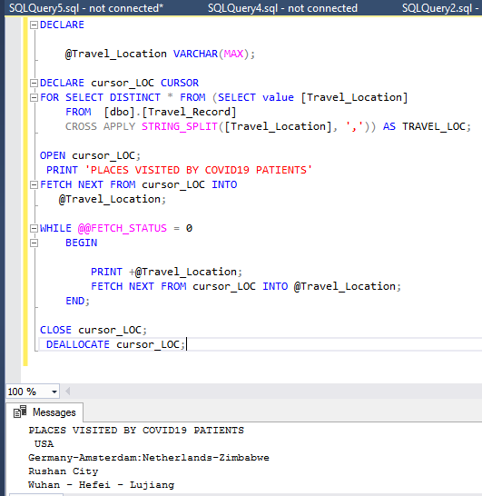

O

## COMMON TABLE EXPRESSIONS

1. Find the total cases, total deaths and total recovered patients of COVID-19 in each day of march month

With DATECTE AS(

SELECT cast('03-01-2020' as date) as CalDate

Union ALL

SELECT DATEADD(DAY,1,CalDate) as CalDate

FROM DATECTE

WHERE DATEADD(DAY,1,CalDate)<'04-01-2020')

SELECT DATECTE.CalDate,SUM([Total_Cases]) as [Total_Cases],SUM([Total_deaths]) as Total_Deaths,SUM([Total_Recovered]) as Total_Recovered

FROM DATECTE join [dbo].[Covid19_Census] on [dbo].[Covid19_Census].[Date] = DATECTE.CalDate

Group BY DATECTE.CalDate option (maxrecursion 300) ;

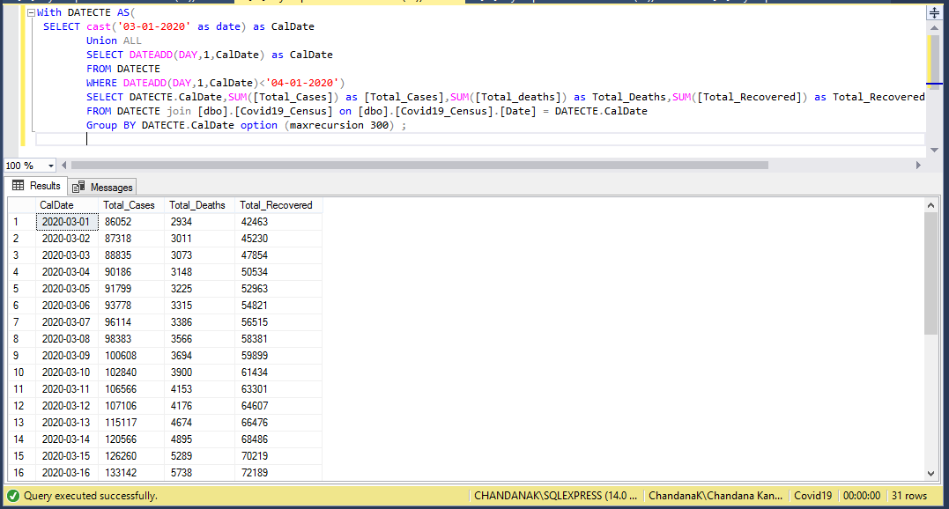

1. Find the count of covid-19 patients recorded as dead in each hospital in different countries, whose count >0

use Covid19;

With OutcomeCTE AS(

Select count(CASE WHEN [Outcome]= 'died' THEN 1 END) as Patients_dead, [Hospital_Name],[dbo].[Patient].[Country_Name]

from [dbo].[Patient] join [dbo].[Hospital] on [dbo].[Patient].Hospital_ID = [dbo].[Hospital].Hospital_ID

Group By [dbo].[Patient].[Country_Name],[Hospital_Name]

)

Select * from OutcomeCTE Where Patients_dead > 0 order by OutcomeCTE.Country_Name

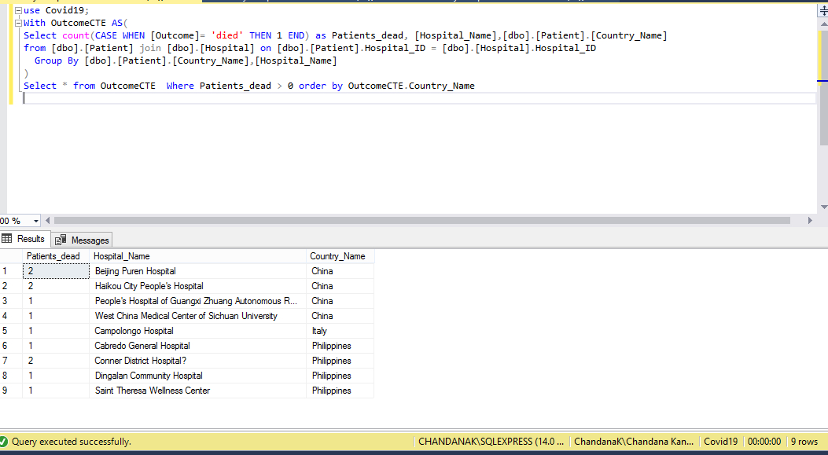

1. Find the count of covid-19 patients recorded as dead in each country, whose count >0

use Covid19;

With OutcomeCTE AS(

Select count(CASE WHEN [Outcome]= 'died' THEN 1 END) as Patients_dead, [Hospital_Name],[dbo].[Patient].[Country_Name]

from [dbo].[Patient] join [dbo].[Hospital] on [dbo].[Patient].Hospital_ID = [dbo].[Hospital].Hospital_ID

Group By [dbo].[Patient].[Country_Name],[Hospital_Name]

)

Select sum(Patients_dead) as Total_Deaths,OutcomeCTE.Country_Name from OutcomeCTE Group by OutcomeCTE.Country_Name

HAVING sum(Patients_dead) > 0

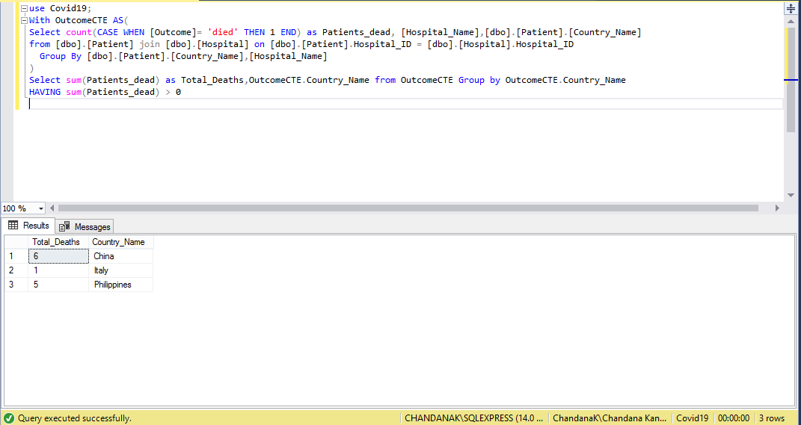

## WINDOW FUNCTIONS -SQL

1. Find the total deaths of patients of COVID-19 date wise

select DISTINCT [Date],SUM([Total_deaths]) over(PARTITION BY [Date] ) as TOTAL_DEATHS from [dbo].[Covid19_Census]

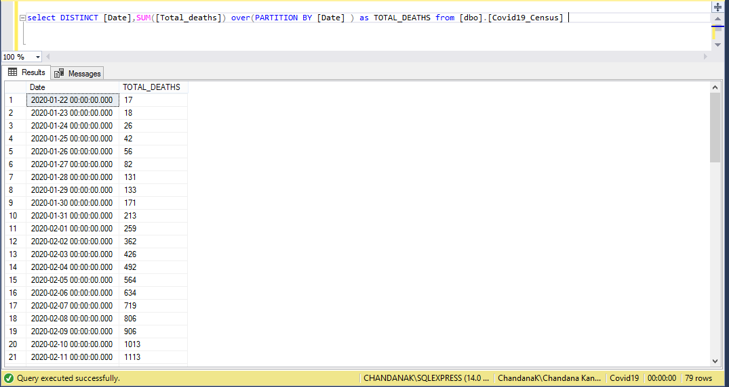

1. Find the no. of symptoms in each COVID-19 patient

Select [Patient_ID],[Age],[Sex],[Date_Onset_Symptoms],[Symptoms],Count( [Symptoms] )over(PARTITION BY[Patient_ID]) as NumberOfSymptoms

from [dbo].[Patient] CROSS APPLY STRING_SPLIT([Symptoms], ',')

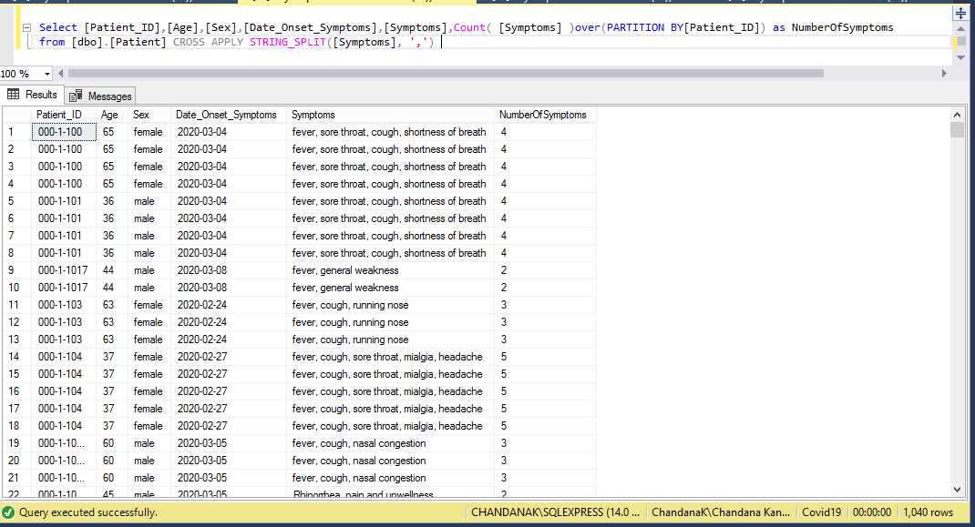

## VIEWS

1. VIEW FOR COUNTRIES WHOSE GDP IMPROVED

CREATE VIEW Positive_GDP

AS

SELECT Country_Name,GDP_fall_percentage FROM C

WHERE GDP_fall_percentage > 0;

go

select * from Positive_GDP

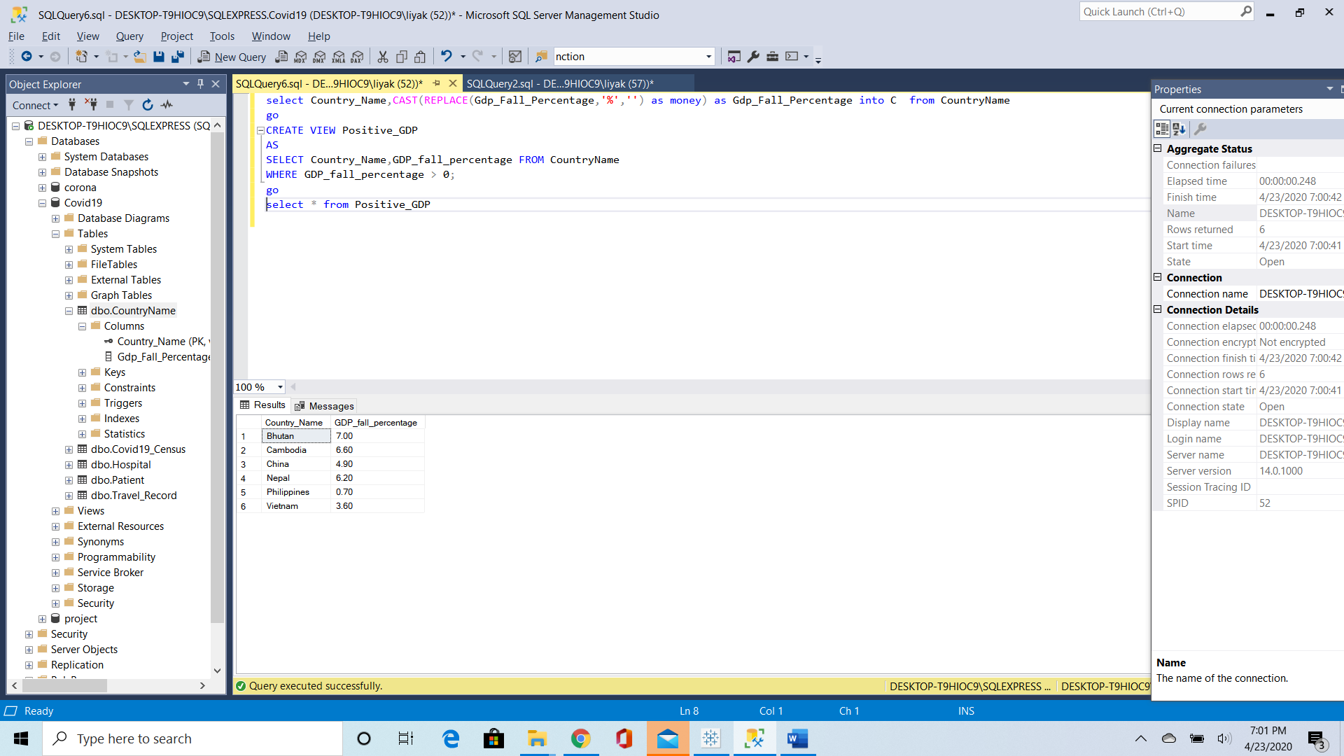

1. VIEW FOR COUNTRIES WHOSE TOTAL GDP Increase

CREATE VIEW TOTALPOSITIVE_GDP

AS

SELECT COUNT(Country_Name) AS Total_Countries,

SUM(GDP_fall_percentage)

AS TOTAL_POSITIVE_GDP FROM C

WHERE GDP_fall_percentage > 0;

go

select * from TOTALPOSITIVE_GDP

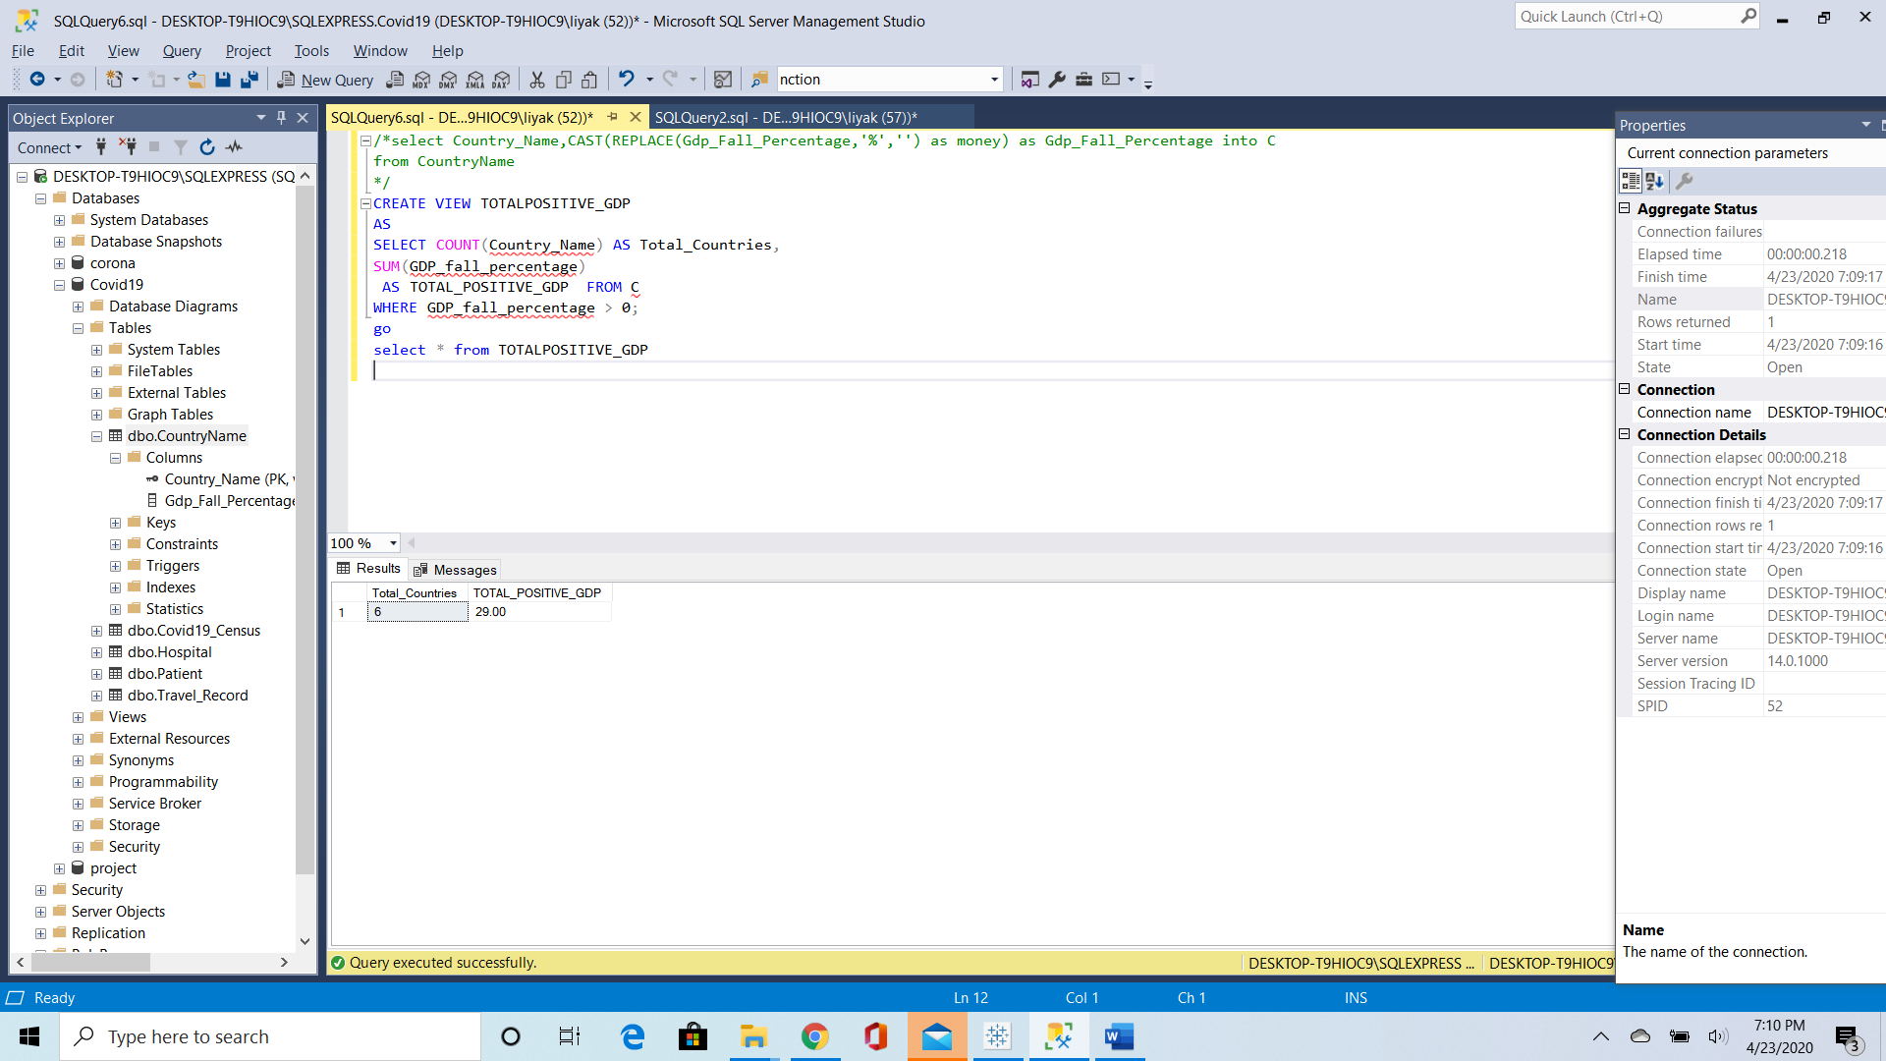

1. VIEW FOR COUNTRIES WHOSE GDP DECREASED

CREATE VIEW NEGATIVE_GDP

AS

SELECT Country_Name,GDP_fall_percentage FROM C

WHERE GDP_fall_percentage <0;

Go

select * from NEGATIVE_GDP

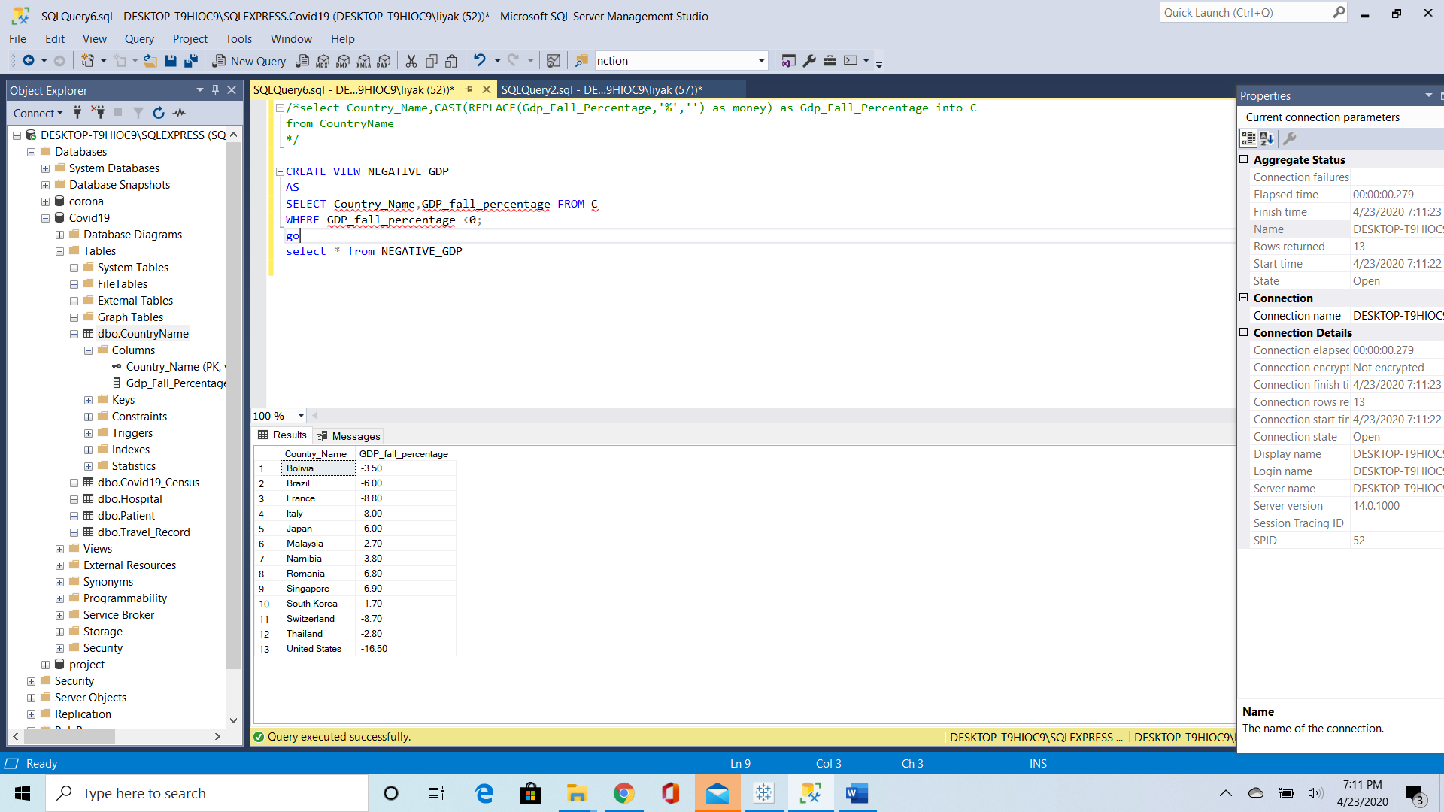

1. VIEW FOR COUNTRIES WHOSE TOTAL GDP DECREASED

CREATE VIEW TOTALNEGATIVE_GDP

AS

SELECT COUNT(Country_Name) AS Total_Countries,SUM(GDP_fall_percentage)

AS TOTAL_NEGATIVE_GDP FROM C

WHERE GDP_fall_percentage < 0;

go

select * from TOTALNEGATIVE_GDP

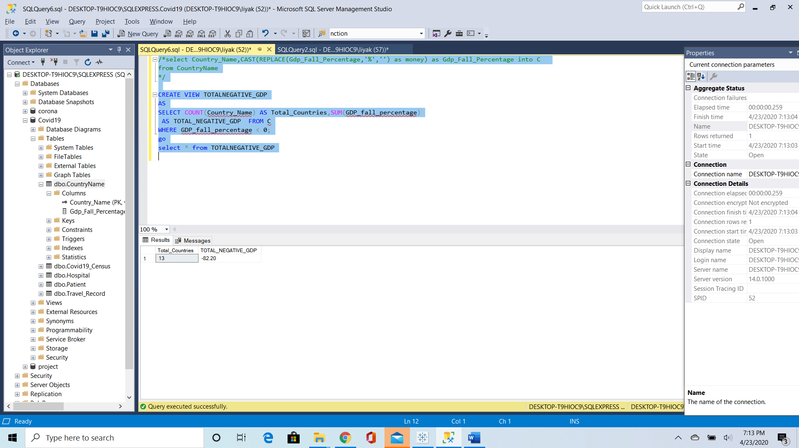

1. View to put Patient Data Confidential and let others use this data for research

CREATE VIEW Patients

AS

SELECT Patient_ID,Country_Name,Hospital_ID,

Date_admitted_to_hospital, Symptoms from Patient

go

select * from Patients

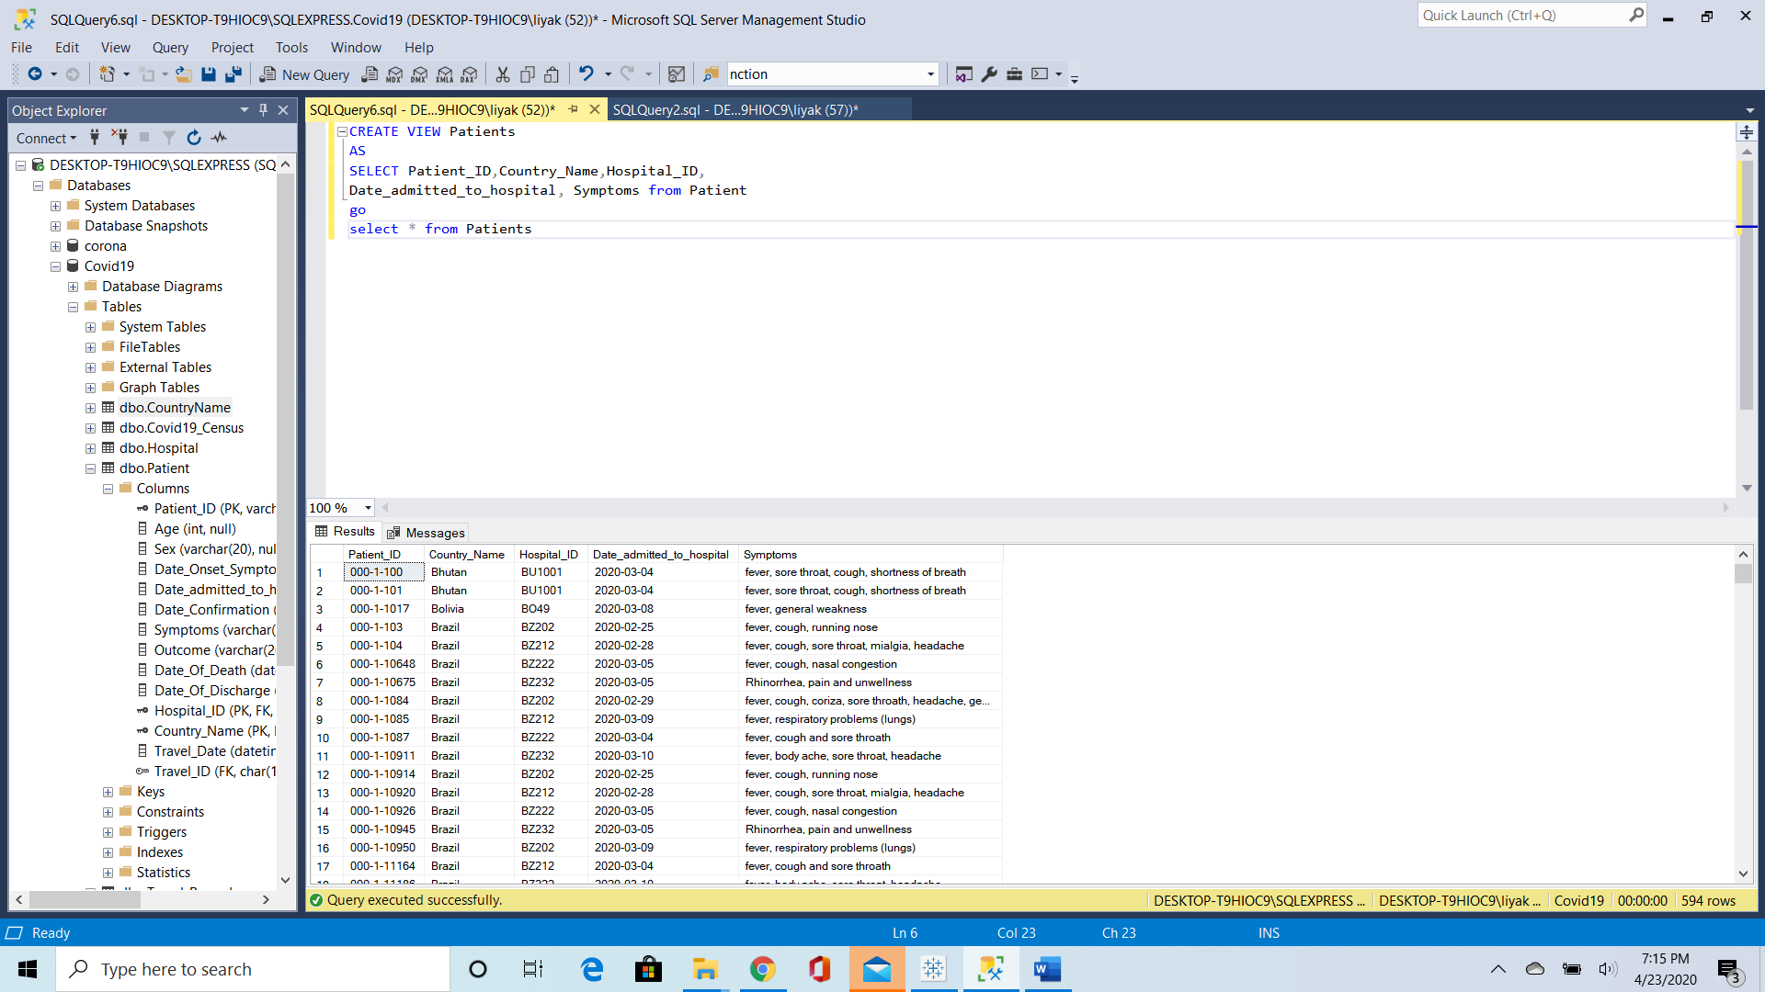

## STORED PROCEDURE

1. STORAGE PROCEDURE TO COUNT NUMBER OF CASES AND DEATHS

IF OBJECT_ID('spCountcases') is not null

drop proc spCountcases

go

create proc spCountcases

@start_date smalldatetime='2020-01-01',

@end_date smalldatetime='2020-05-05'

as

select Total_cases,Total_deaths Country_Name,date from Covid19_Census

where date between @start_date and @end_date

go

exec spCountcases

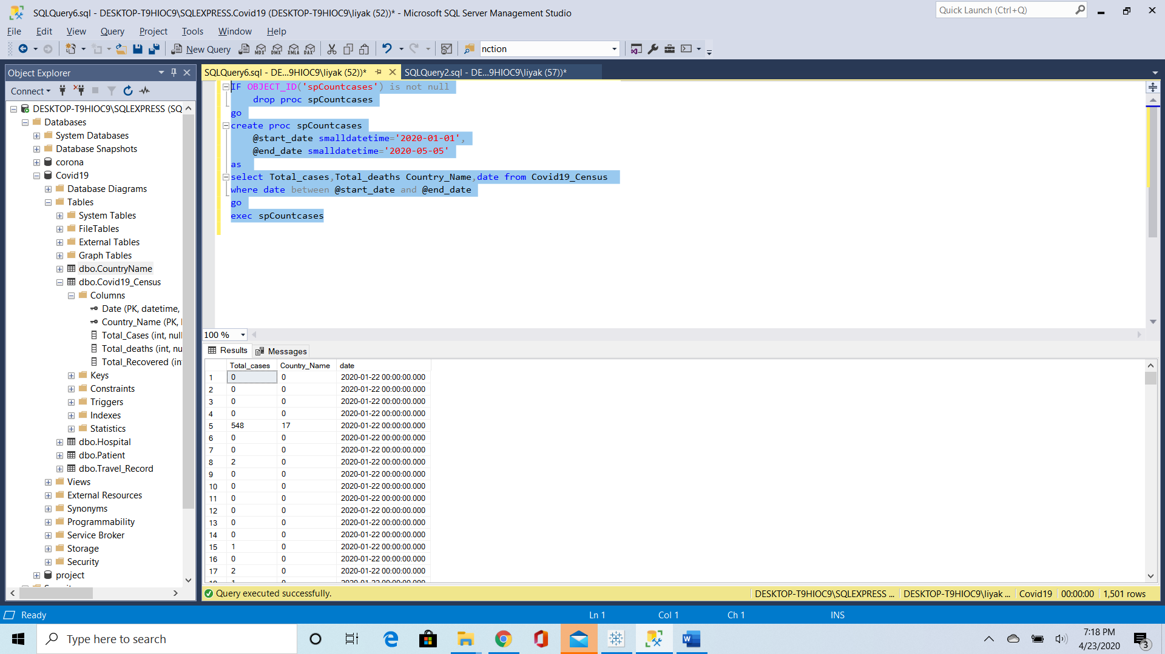

1. STORAGE PROCEDURE TO TOTAL COUNT OF NUMBER OF CASES AND DEATHS

if OBJECT_ID('spTotalcases') is not null

drop proc spTotalcases

go

create proc spTotalcases

@start_date smalldatetime='2020-01-01',

@end_date smalldatetime='2020-05-05'

as

select sum(Total_cases) as totalcases, sum(Total_deaths) as totaldeaths

from Covid19_Census where date between @start_date and @end_date

go

exec spTotalcases

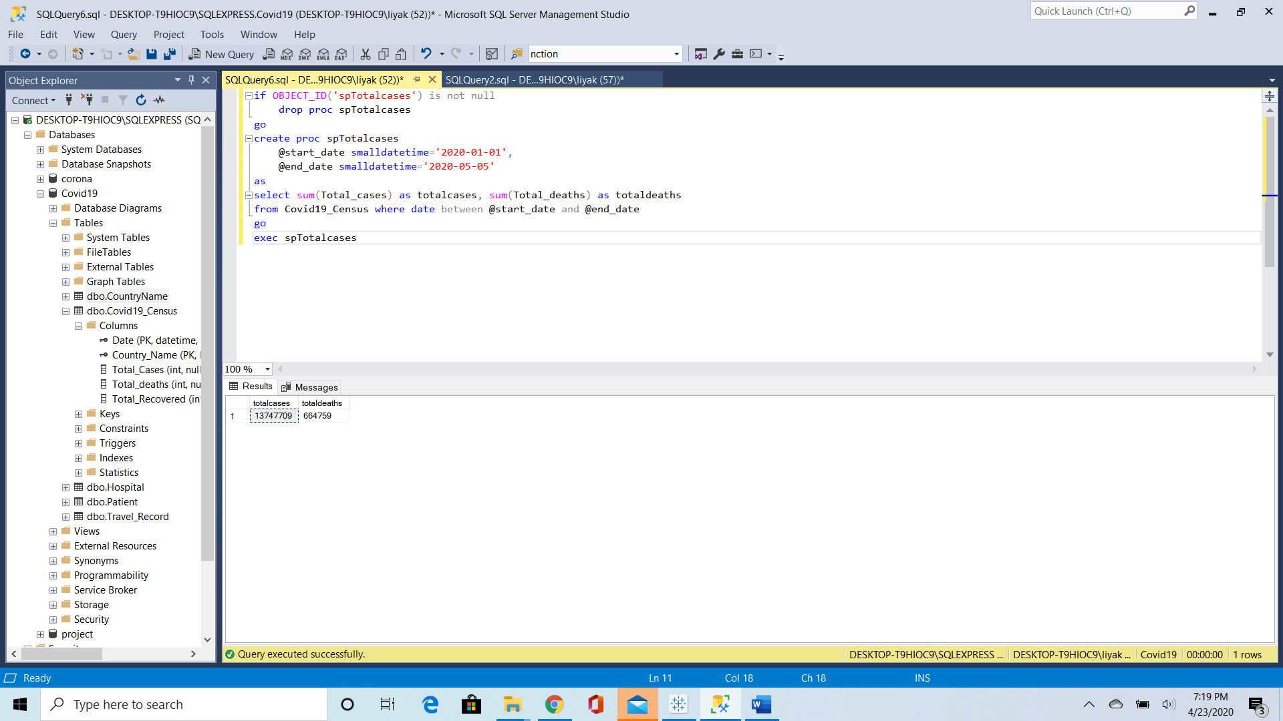

1. STORAGE PROCEDURE TO KNOW NO OF PATIENTS IN EACH HOSPITAL

if OBJECT_ID('spGROUP_PATIENTSBY_HOSPITAL') is not null

drop proc spGROUP_PATIENTSBY_HOSPITAL

go

create proc spGROUP_PATIENTS_HOSPITAL

as

select Count(Patient_ID) as TOATL_PATIENTS,Hospital_Name from PATIENT p join Hospital h on p.Hospital_ID = h.Hospital_ID

GROUP BY Hospital_Name

go

exec spGROUP_PATIENTS_HOSPITAL

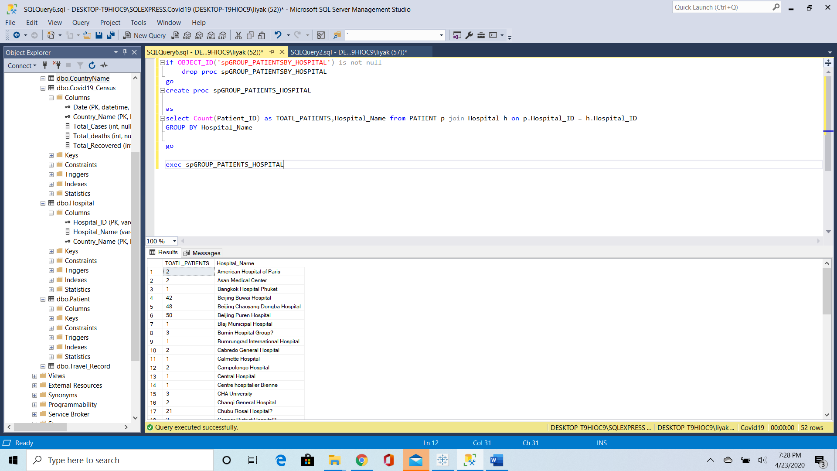

1. STORED PROCEDURE TO KNOW TOTAL CASES BY DATE

if OBJECT_ID('spGROUPBY_DATE_CASES') is not null

drop proc spGROUPBY_DATE_CASES

go

create proc spGROUPBY_DATE_CASES

as

select sum(Total_cases) as Total_cases,

sum(Total_deaths) as Total_deaths, date from Covid19_Census

group by date

go

exec spGROUPBY_DATE_CASES

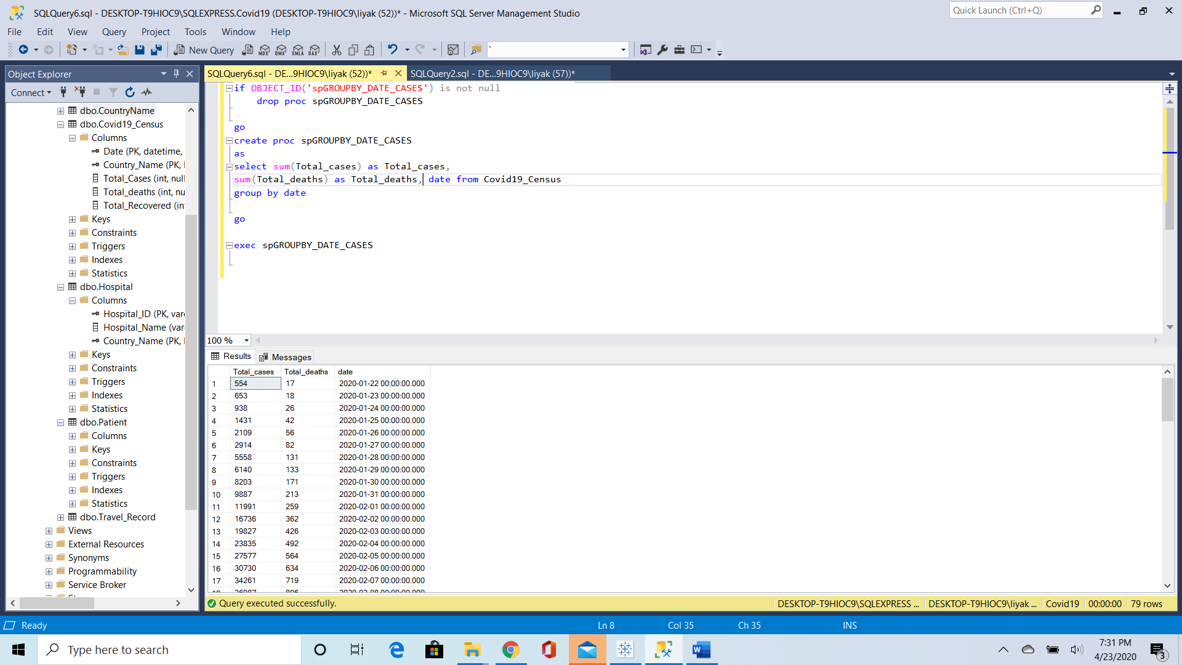

1. STORED PROCEDURE TO COUNT TOTAL CASES GROUP BY COUNTRY FILTER BY DATE CONSTRAINT

if OBJECT_ID('spGROUPBY_DATE_CASES') is not null

drop proc spGROUPBY_DATE_CASES

go

create proc spGROUPBY_DATE_CASES

@start_date smalldatetime='2020-01-01',

@end_date smalldatetime='2020-05-05'

as

select sum(Total_cases) as Total_cases,

sum(Total_deaths) as Total_deaths,Country_Name from Covid19_Census

group by Country_Name

go

exec spGROUPBY_DATE_CASES

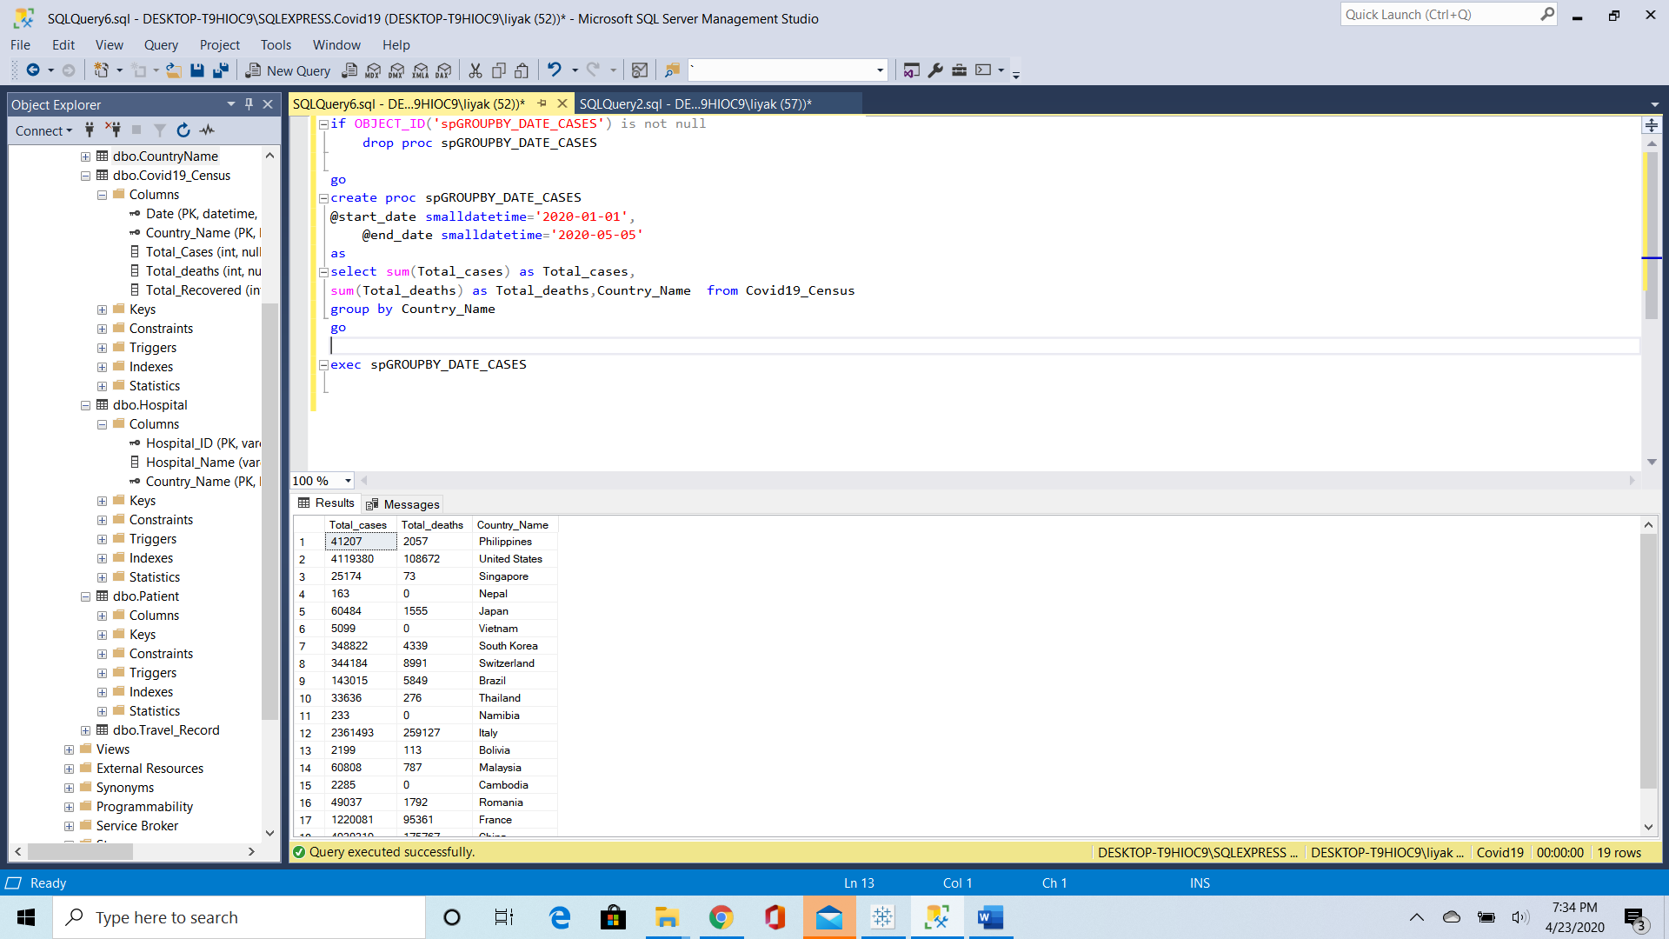

1. USER DEFINED FUNCTION TO COUNT NUMBER OF HOSPITALS BY COUNTRY NAME

CREATE FUNCTION dbo.fnTotalHospitals

(@country varchar(50)='United States')

Returns table

RETURN

(select Count(Hospital_ID) as Total_hospital, Country_Name from Hospital

where Country_Name=@country

group by Country_Name)

go

select * from fnTotalHospitals('Brazil')

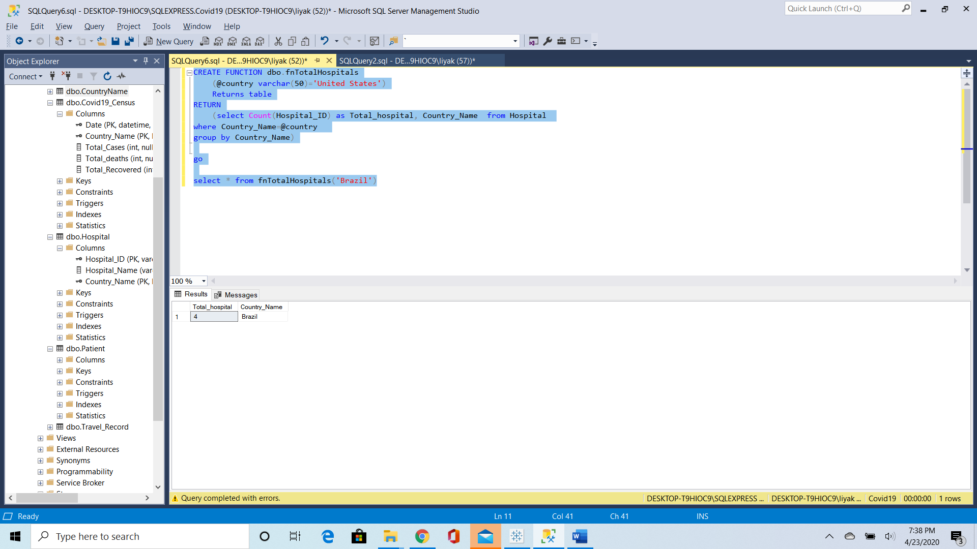

## TRIGGER

This trigger stores the deleted data from patient into patient archive:

This usually happens due to increase in patient data but limited storage

* CREATING TABLE PATIENTARCHIVE

CREATE TABLE PatientArchive

(

[Patient_ID] varchar(20) NOT NULL ,

[Age] integer NULL ,

[Sex] varchar(20) NULL ,

[Date_Onset_Symptoms] date NULL ,

[Date_admitted_to_hospital] date NULL ,

[Date_Confirmation] date NULL ,

[Symptoms] varchar(100) NULL ,

[Outcome] varchar(20) NULL ,

[Date_Of_Death] date NULL ,

[Date_Of_Discharge] date NULL ,

[Hospital_ID] varchar(20) NOT NULL ,

[Country_Name] varchar(50) NOT NULL ,

[Travel_Date] datetime NULL ,

[Travel_ID] char(18) NULL

)

CREATE TRIGGER Patient_DELETE

on Patient

after DELETE

as

INSERT INTO PatientArchive(Patient_ID,Country_Name,Hospital_ID,Age,Sex,Date_Onset_Symptoms,Date_admitted_to_hospital,

Date_confirmation,Symptoms,Outcome,Date_of_death,Date_of_discharge)

SELECT Patient_ID,Country_Name,Hospital_ID,Age,Sex,Date_Onset_Symptoms,Date_admitted_to_hospital,

Date_confirmation,Symptoms,Outcome,Date_of_death,Date_of_discharge FROM Deleted

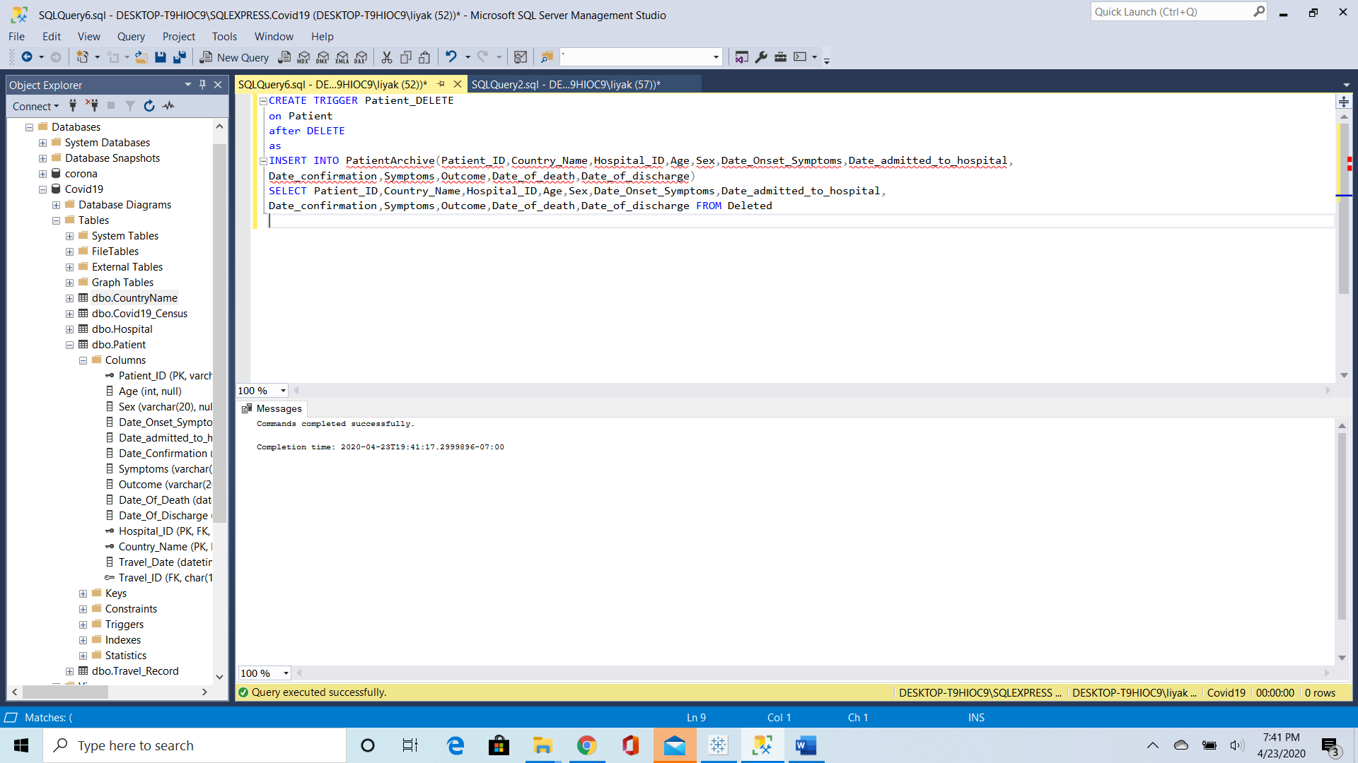

* CHECKING TRIGGER

DELETE FROM Patient WHERE Patient_ID='000-1-100';

select * from PatientArchive

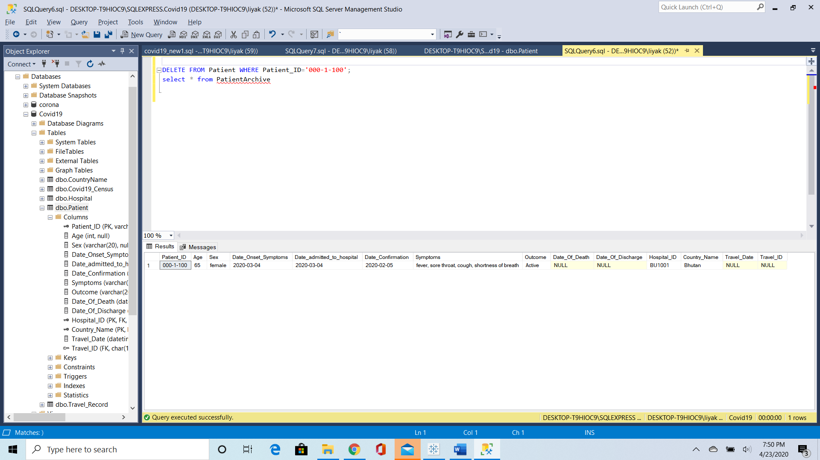

## FUNCTIONS

1. number of active cases in the highest affected country

create function fnactivestatus()

returns int

begin

RETURN(Select top 1 ([Total_Cases]-[Total_deaths]-[Total_Recovered]) as active_cases

from [dbo].[Covid19_Census] order by active_cases desc)

end;

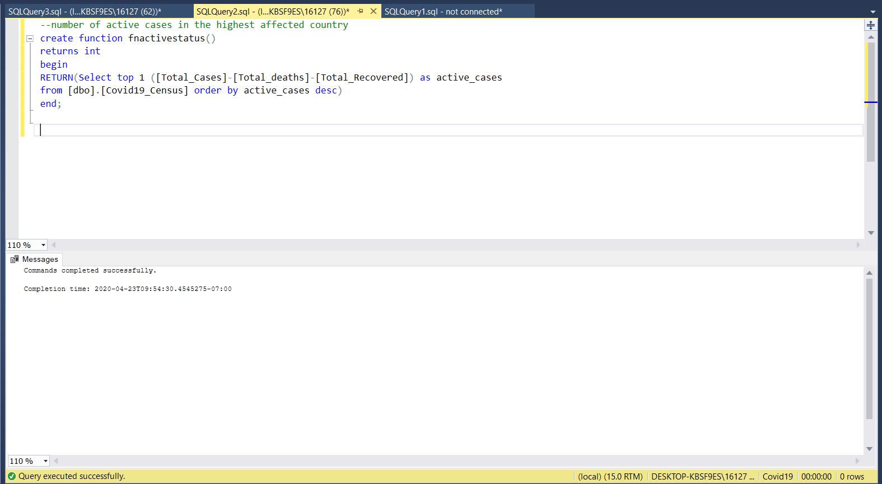

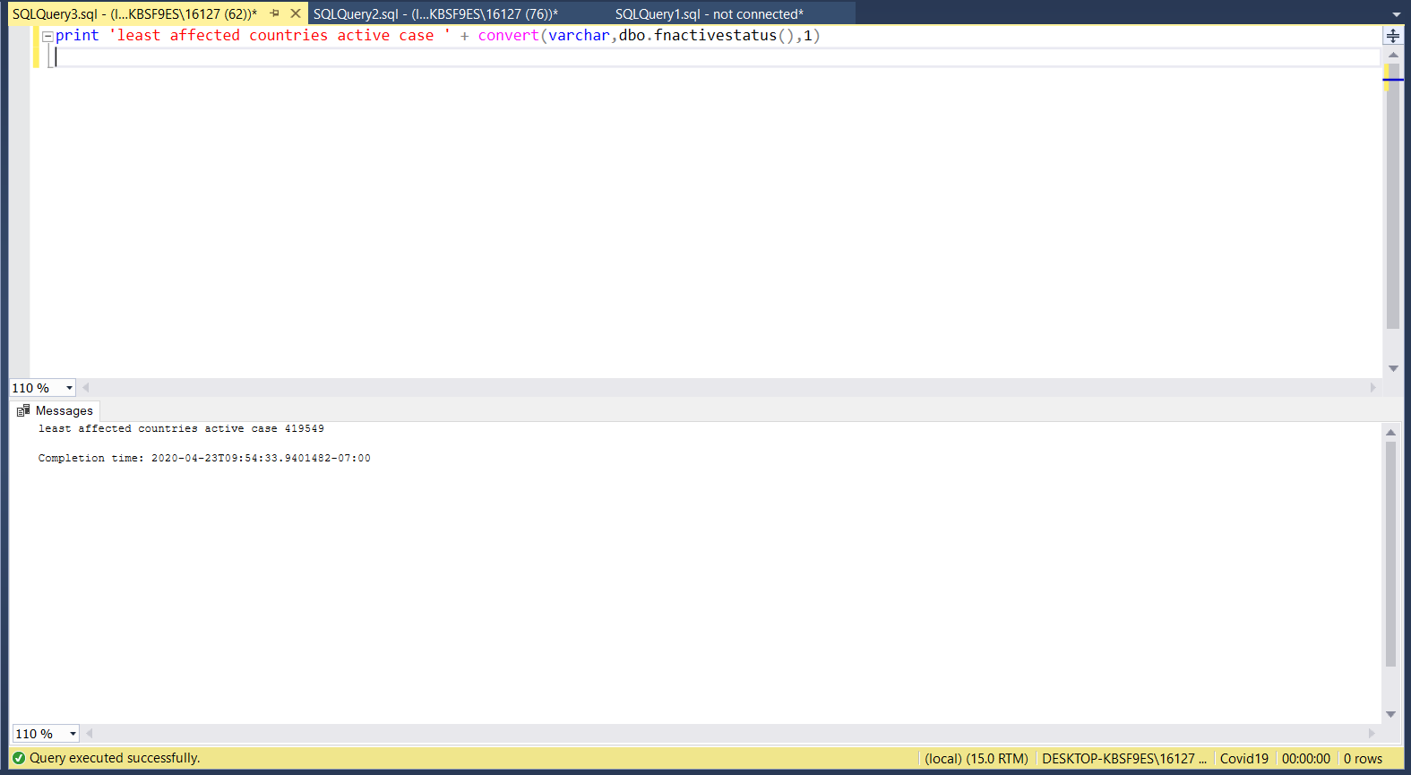

1. Status of the patients who got admitted within the specified number of days after having symptoms

create function fnpatientoutcome(

@noofdays int=0)

returns table

return

(

select p.[Age],p.[Sex],p.[Outcome], h.[Hospital_Name] from [dbo].[Patient] p

left join [dbo].[Hospital] h

on

p.[Hospital_ID]=h.[Hospital_ID]

where datediff(day,[Date_Onset_Symptoms],[Date_admitted_to_hospital])<=@noofdays

)

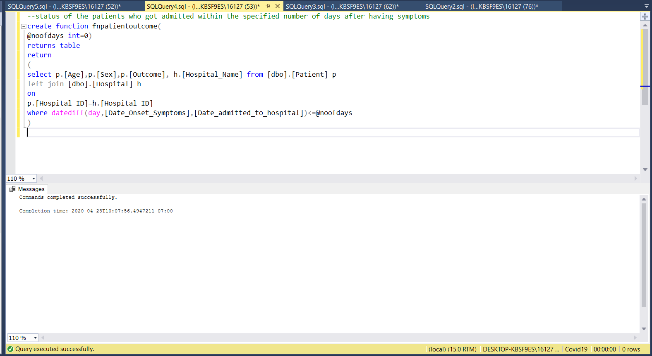

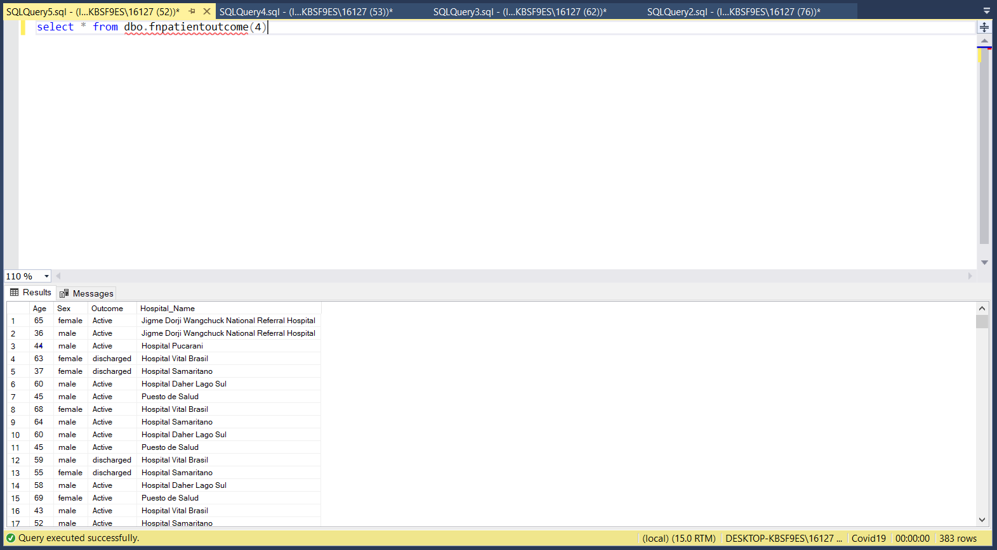

1. updates the patient status as critical if they are in hospital active for more than provided input days

create function fnupdatepatients

(

@days int

)

returns @outtable table

(

age int,sex varchar(10),outcome varchar(30),hospital varchar(100),date_confirmation date

)

Begin

insert @outtable

select p.[Age],p.[Sex],p.outcome,h.[Hospital_Name],p.[Date_Confirmation] from [dbo].[Patient] p

left join

[dbo].[Hospital] h

on

p.Hospital_ID=h.Hospital_ID

where Date_Of_Discharge Is null and Date_Of_Death is null

and Date_admitted_to_hospital is not null

if exists (SELECT * from @outtable where DATEDIFF(day,[Date_Confirmation],getdate()) > @days )

update @outtable

set outcome='critical'

return

end;

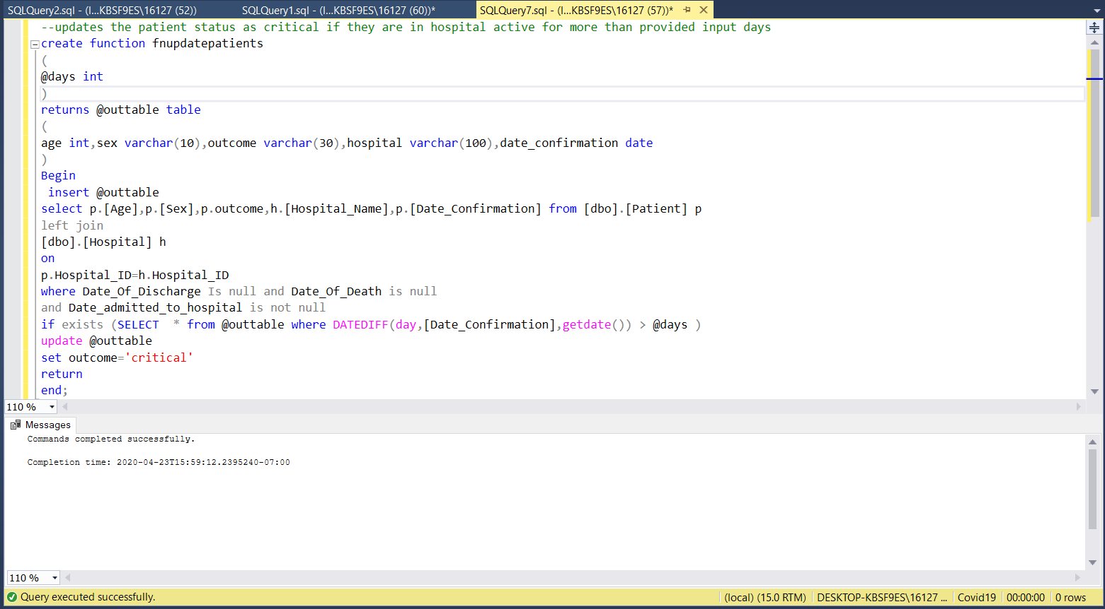

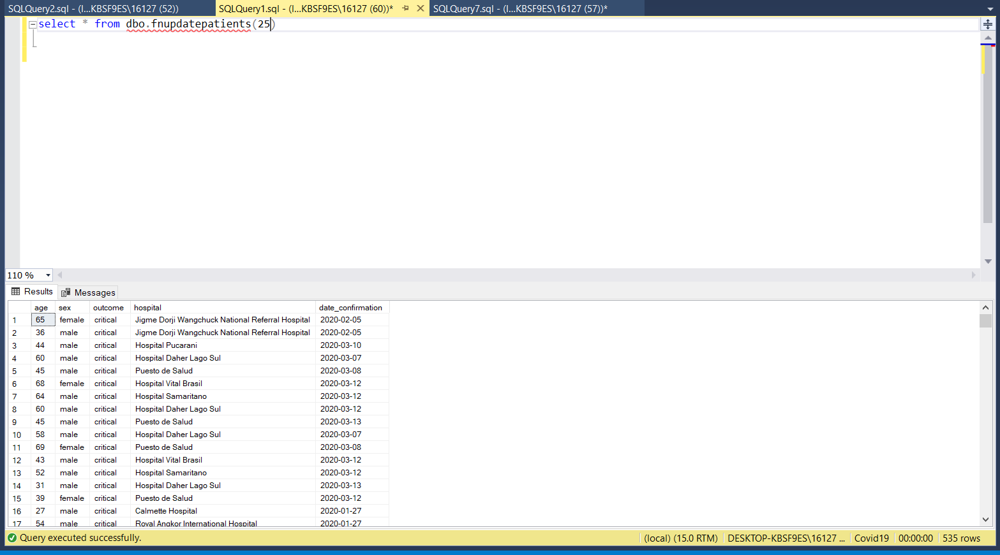

1. Active cases as per specified country

create function fnactivecase(

@countryname varchar(30)

)

returns table

return

(select sum([Total_Cases]-[Total_deaths]-[Total_Recovered]) as Active_Cases from [dbo].[Covid19_Census]

where [Country_Name]=@countryname)

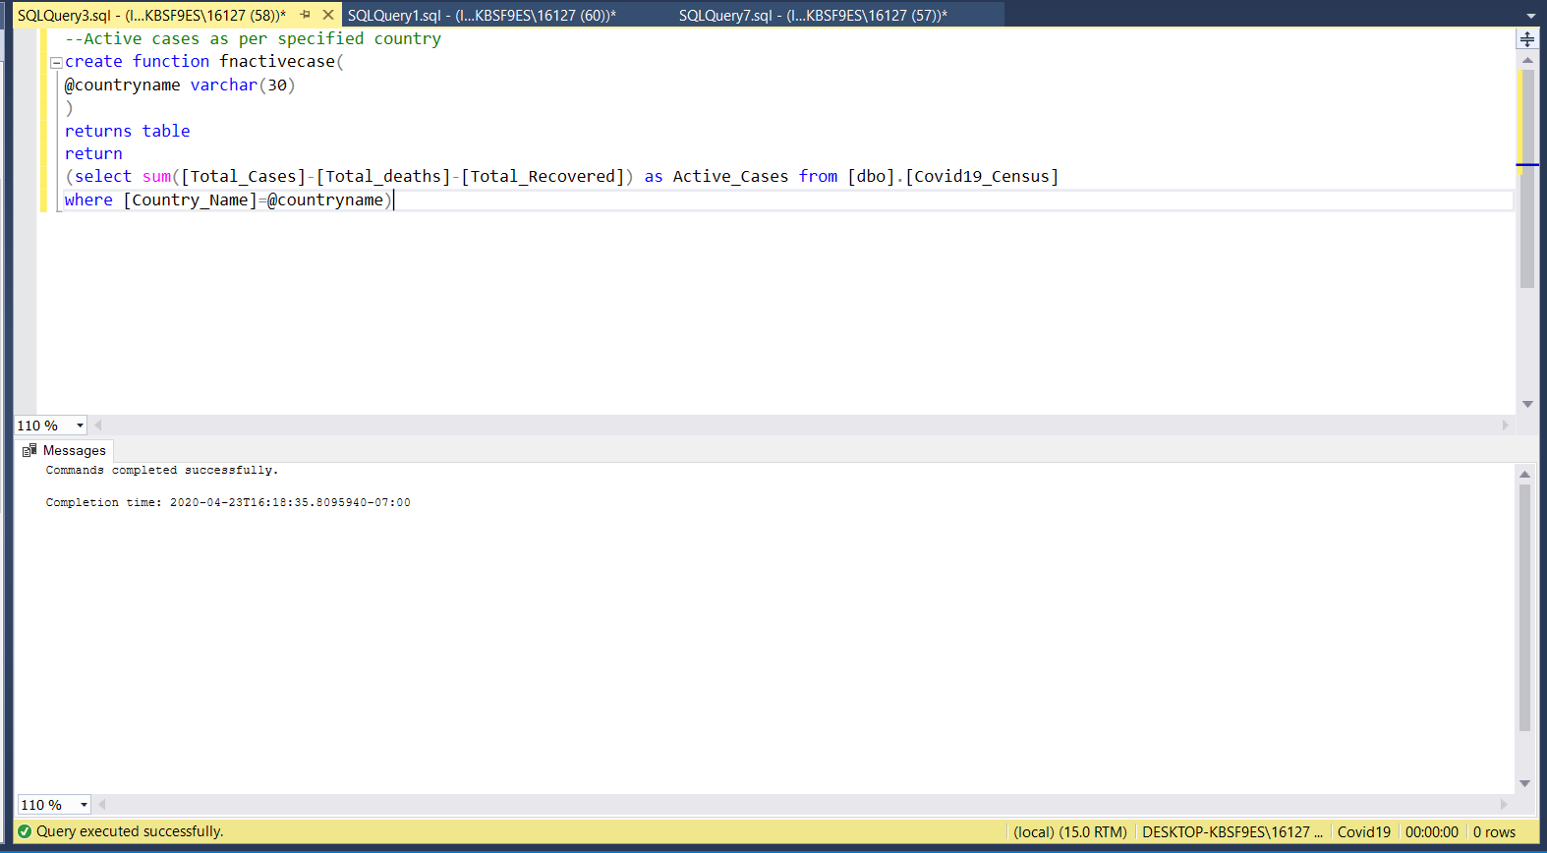

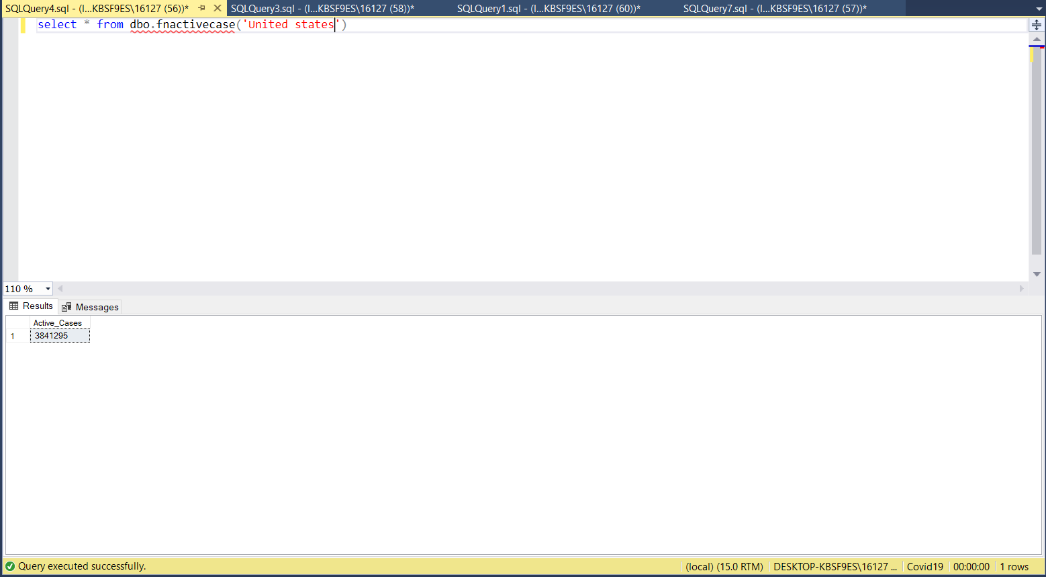

# PART-4

## NOSQL

* CREATING A DATASET:

CREATE DATASET LCountry_project on Country_project

* **CONNECTING THE LINK:**

CONNECT LINK Local

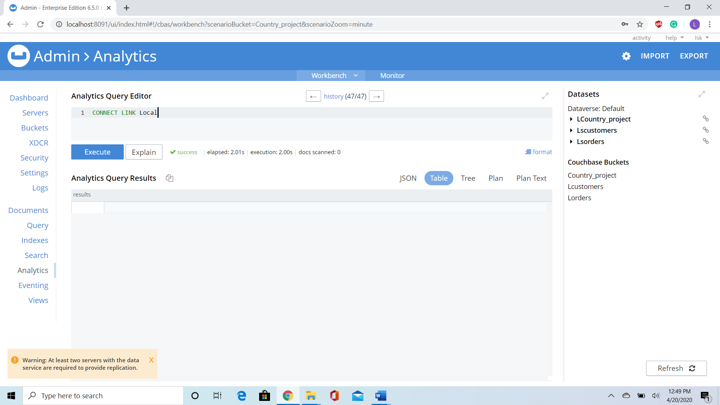

* **CUMULATIVE DISTRIBUTION:**

SELECT c.CountryName ,c.GDP_Growth_or_Fall_Percentage,

CUME_DIST() OVER (

ORDER BY c.GDP_Growth_or_Fall_Percentage DESC ) AS `rank`

FROM LCountry_project AS c

LIMIT 10 ;

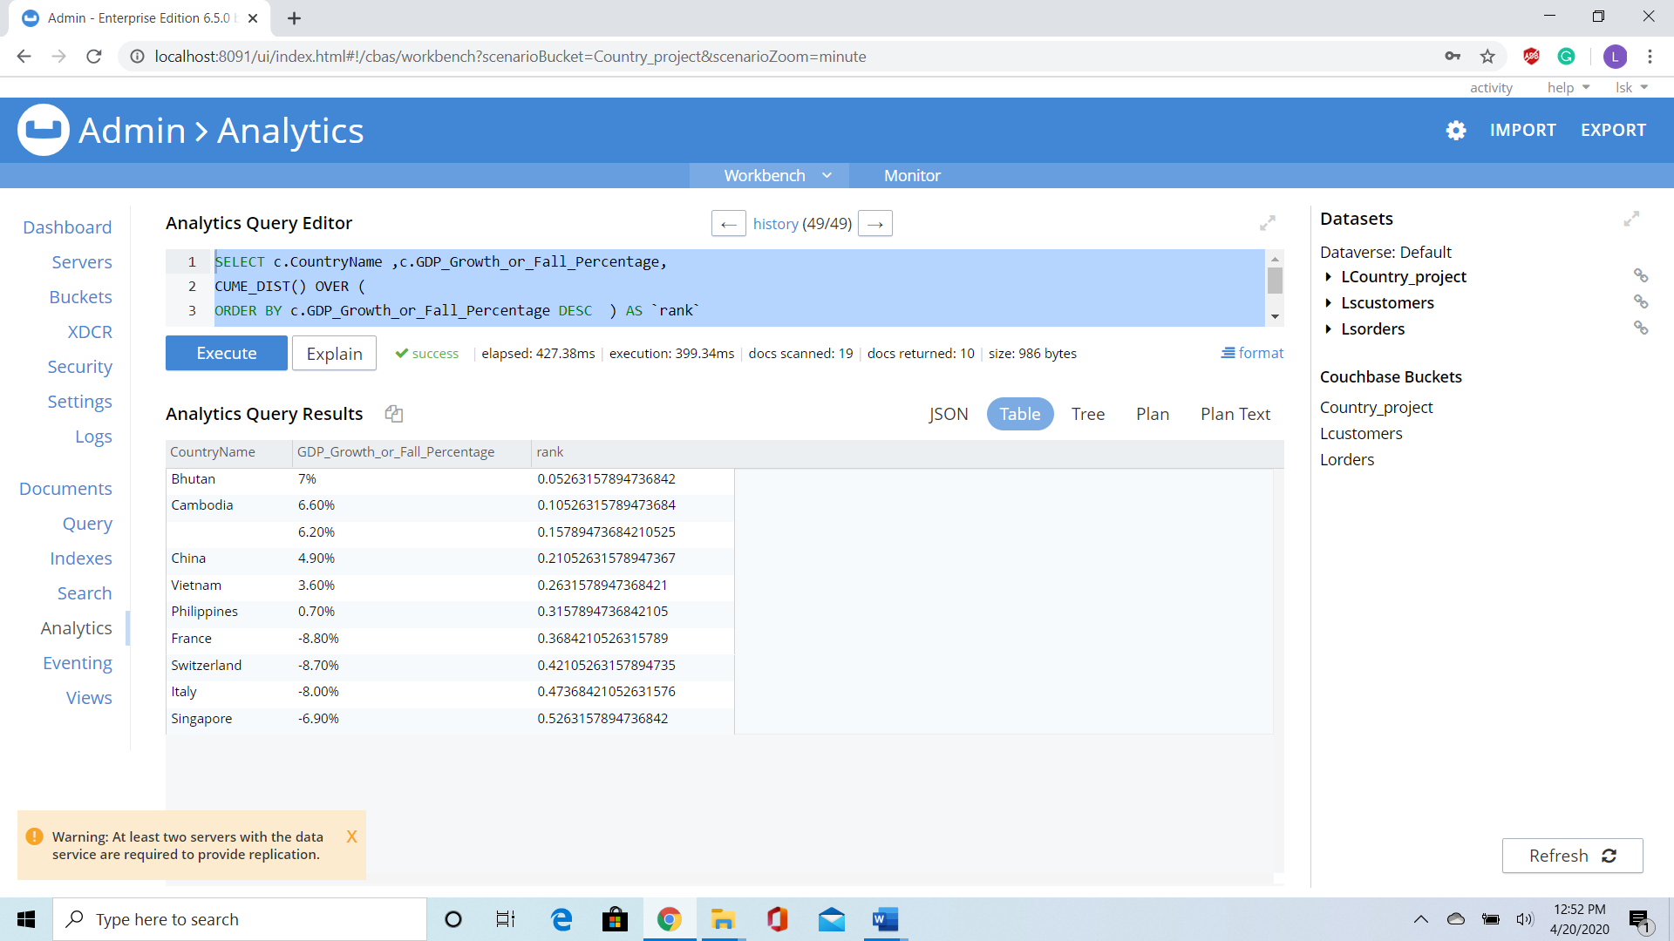

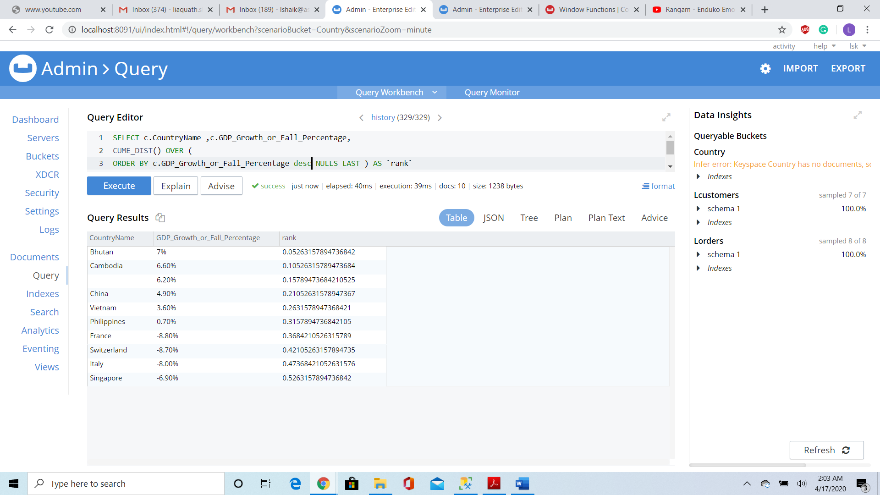

* **DENSE_RANK():**

SELECT c.CountryName ,c.GDP_Growth_or_Fall_Percentage,

DENSE_RANK() OVER (

ORDER BY c.GDP_Growth_or_Fall_Percentage DESC ) AS `rank`

FROM LCountry_project AS c LIMIT 10 ;

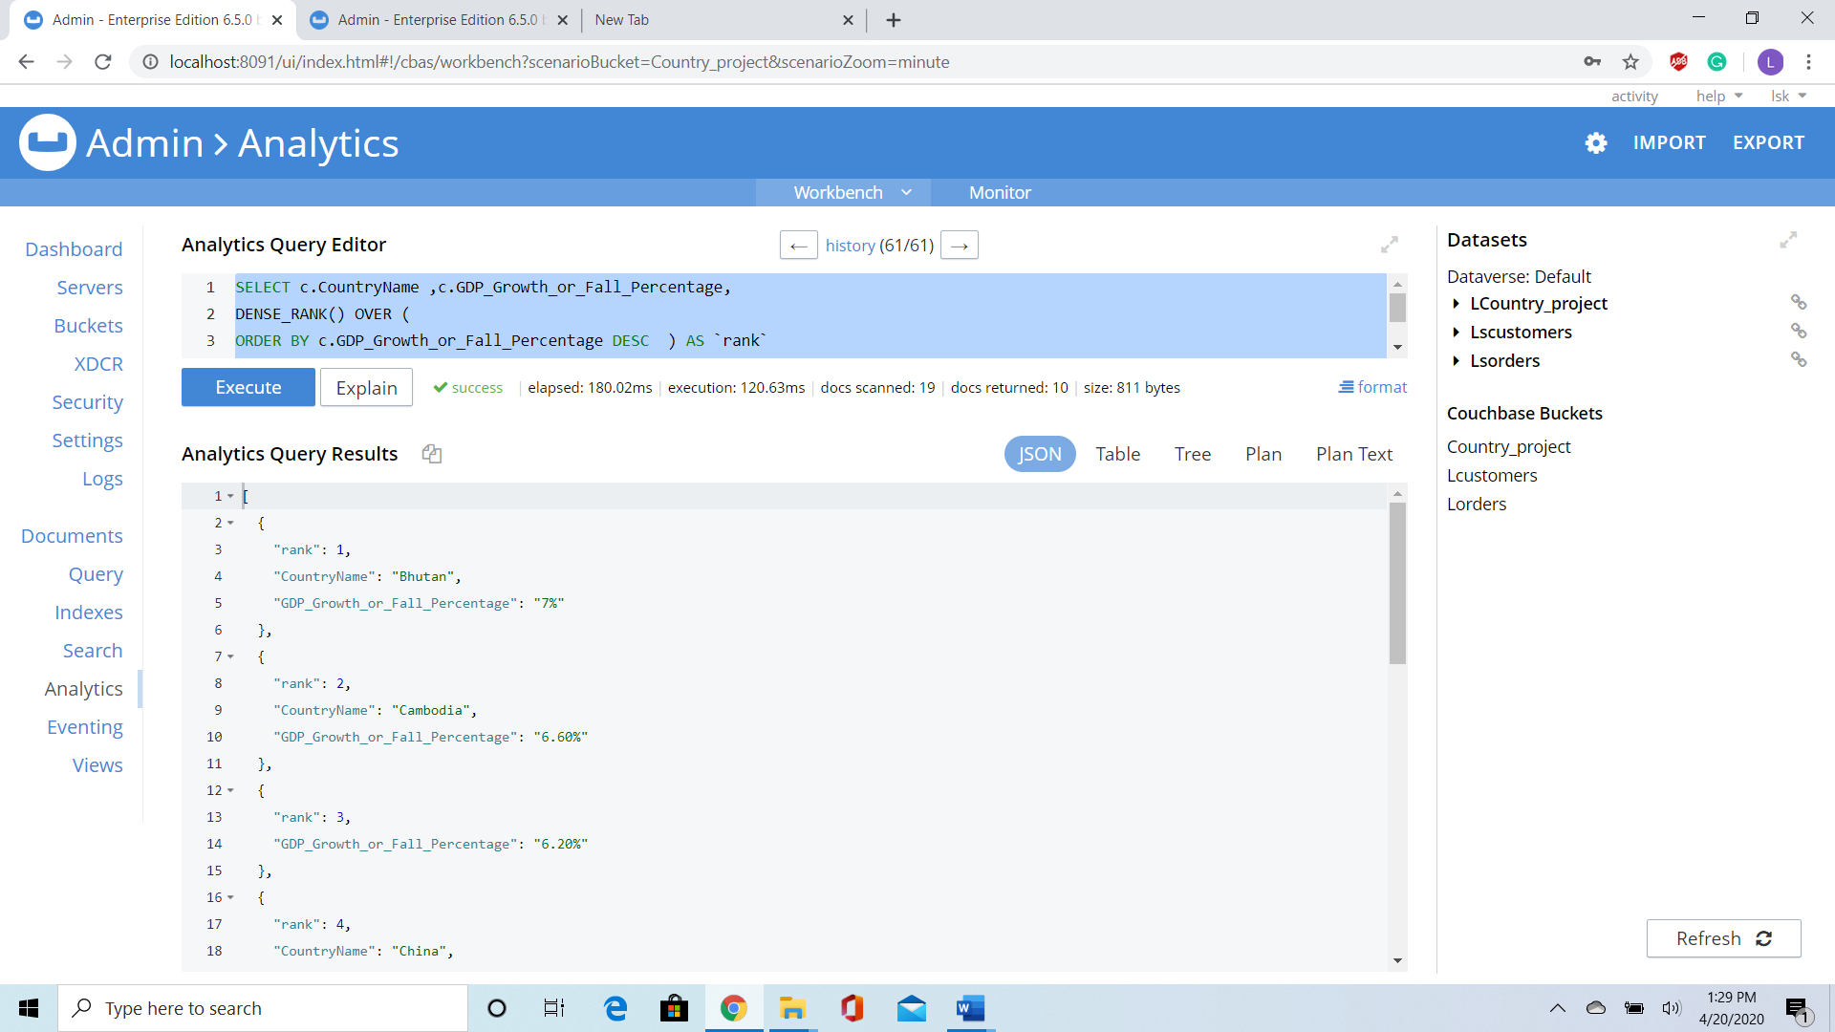

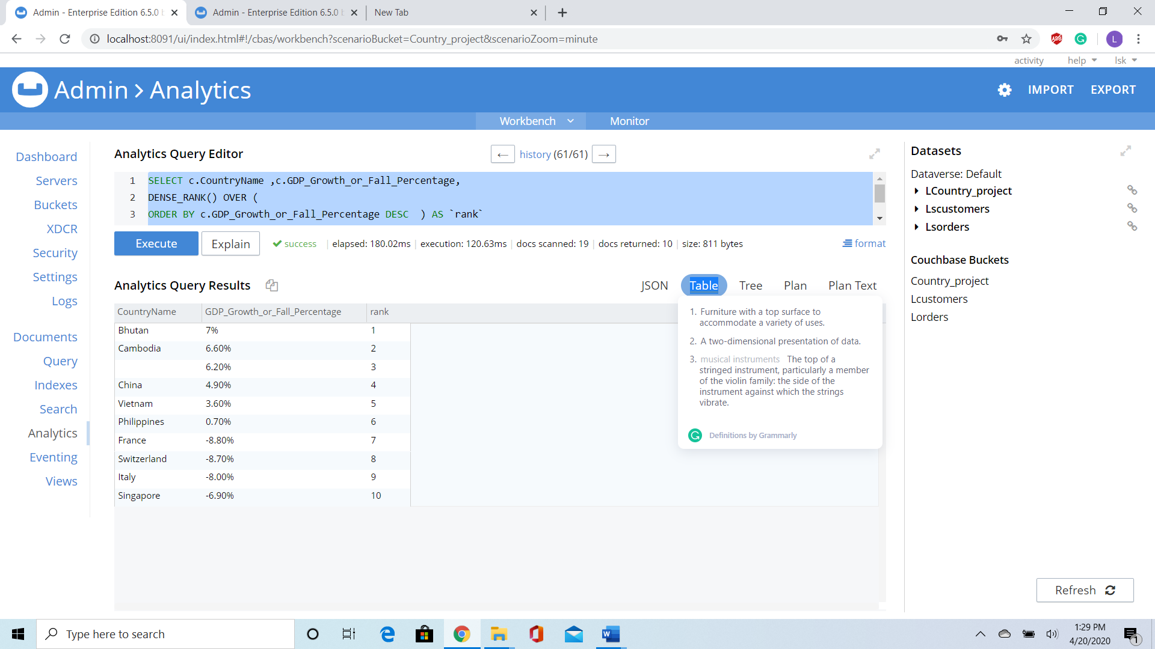

* **USING NTILE FUNCTION ON GDP VALUES OF A COUNTRY**

SELECT c.CountryName ,c.GDP_Growth_or_Fall_Percentage,

NTILE(5) OVER (

ORDER BY c.GDP_Growth_or_Fall_Percentage DESC ) AS `Ntile`

FROM LCountry_project AS c

LIMIT 10 ;

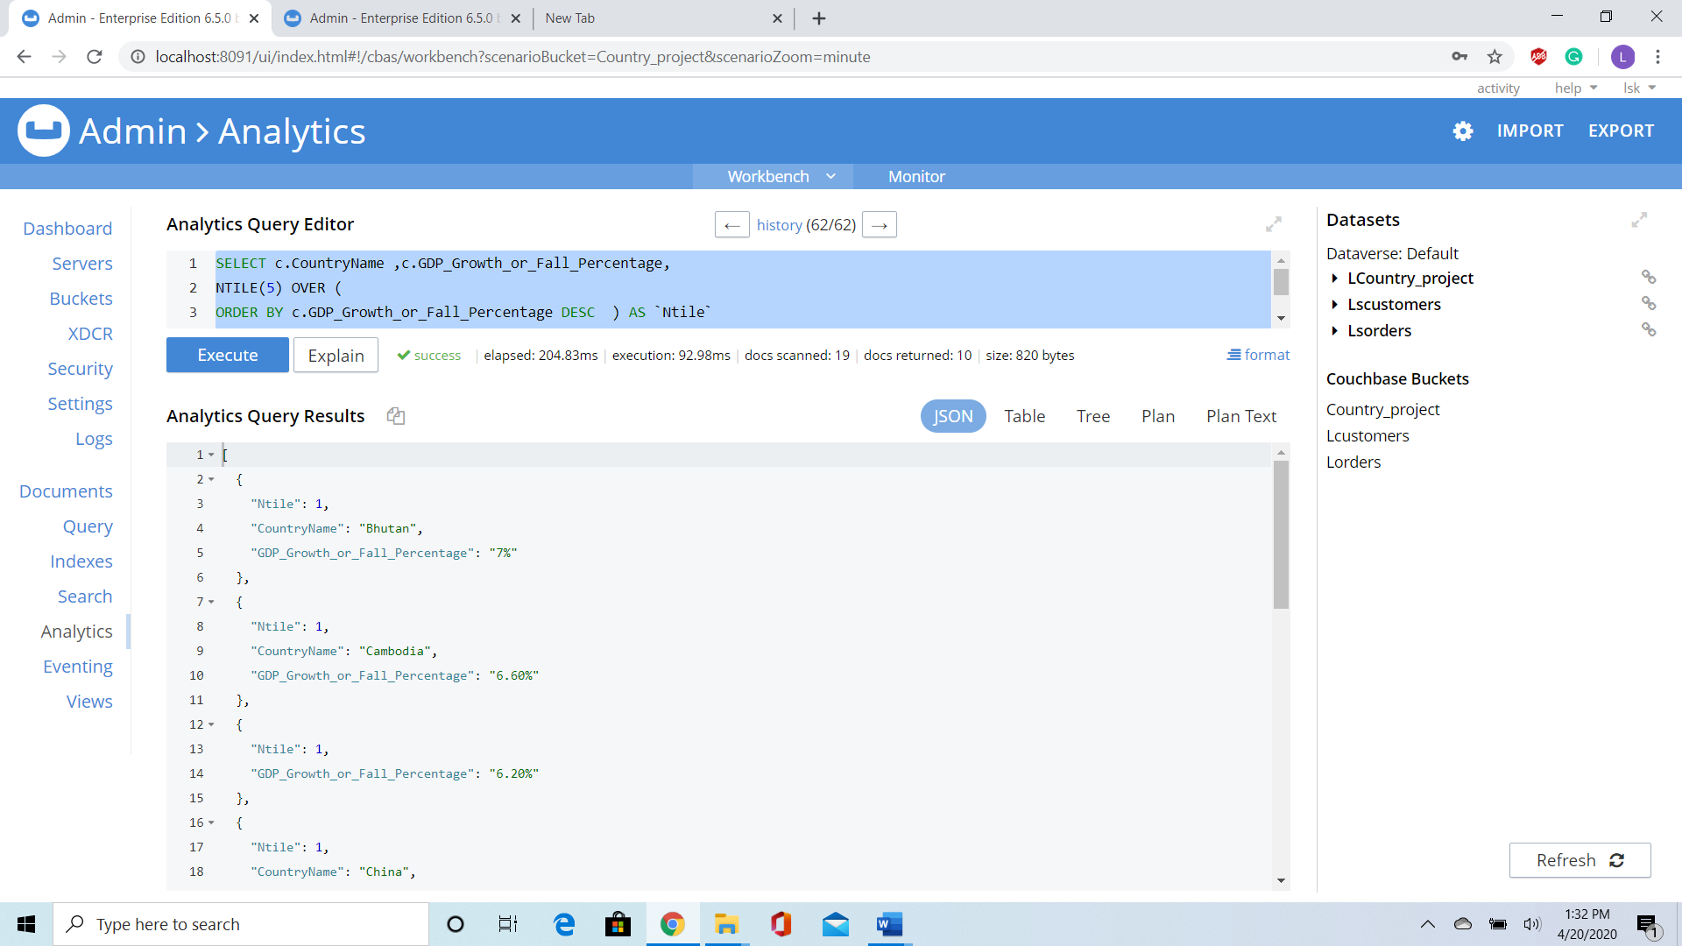

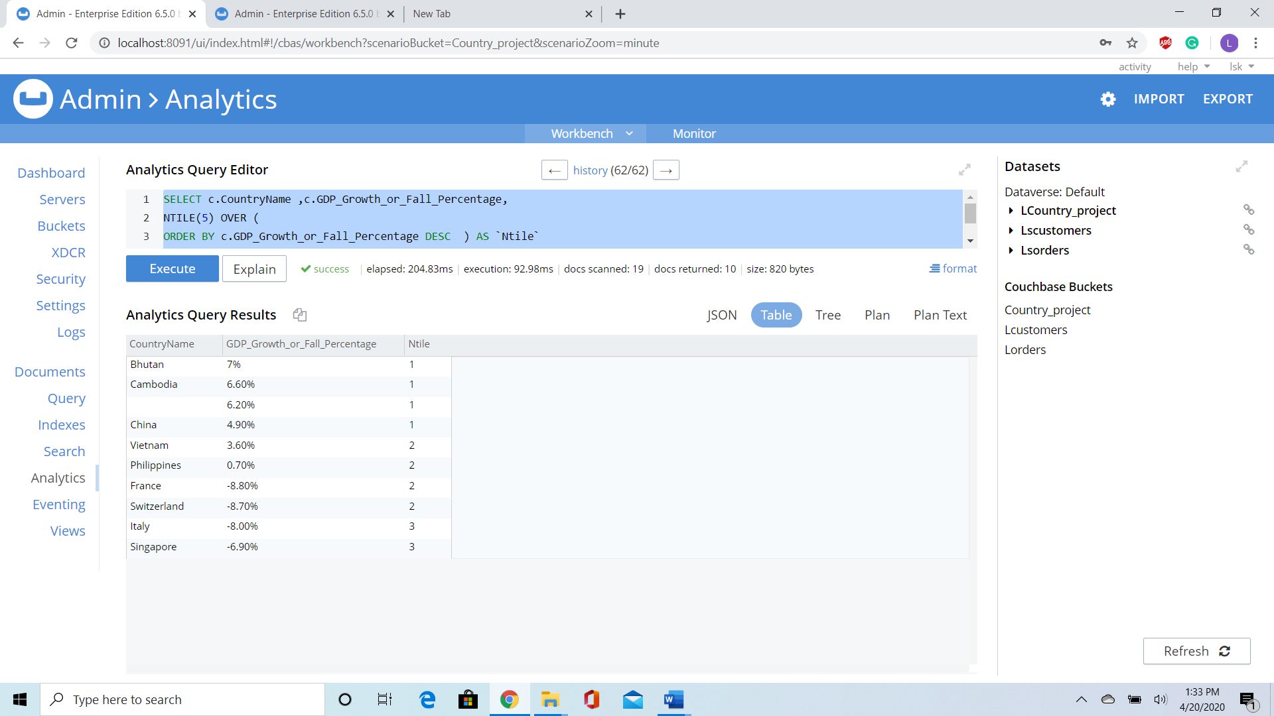

* **Counting Total Number of Hospitals in each Country:**

SELECT DISTINCT c.CountryName ,count(c.Hospital)

OVER (PARTITION by c.CountryName order by c.CountryName ) as Total_Hospital

FROM LCountry_project AS c, c.Hospital as H ;

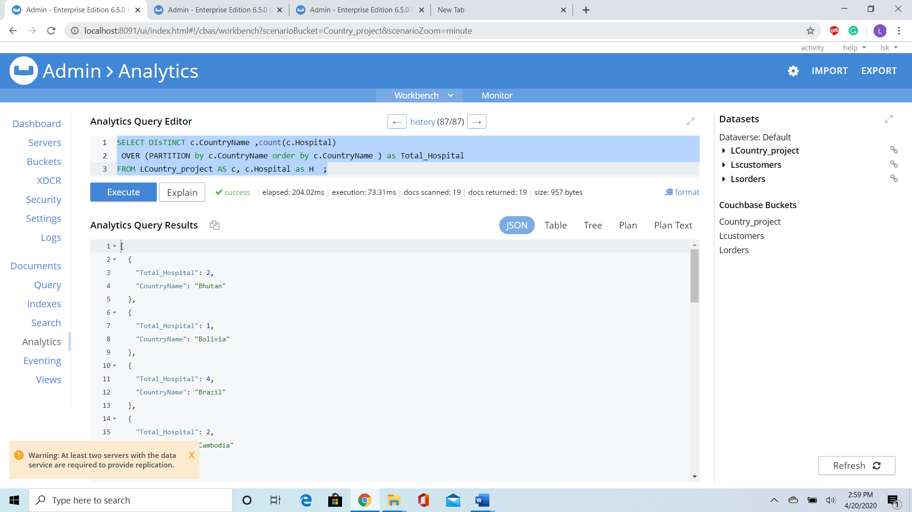

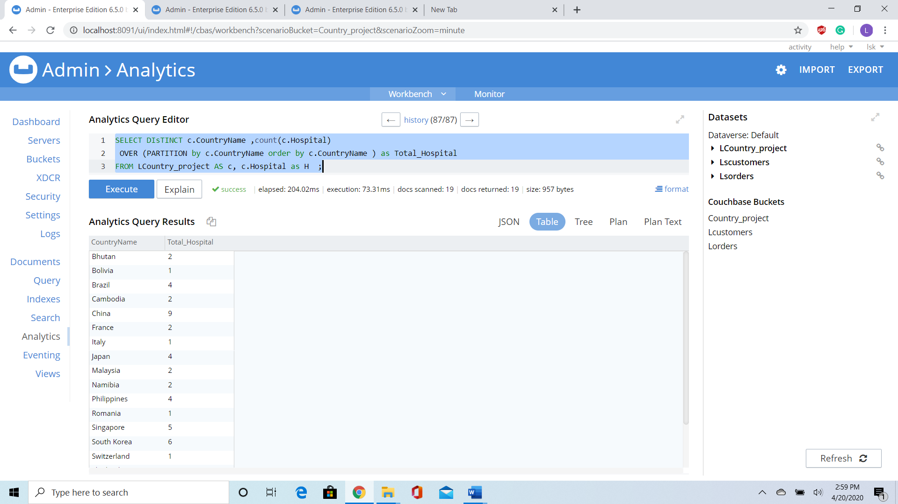

* **PARTITIONING THE TABLE ON COUNTRY AND NAMING ALL THE HOSPITALS IN THE COUNTRY**

SELECT c.CountryName ,H.HospitalID,H.HospitalName,

NTILE(5) OVER (PARTITION by c.Hospital

ORDER BY c.HospialID DESC ) AS `NTILE`

FROM LCountry_project AS c, c.Hospital as H ;

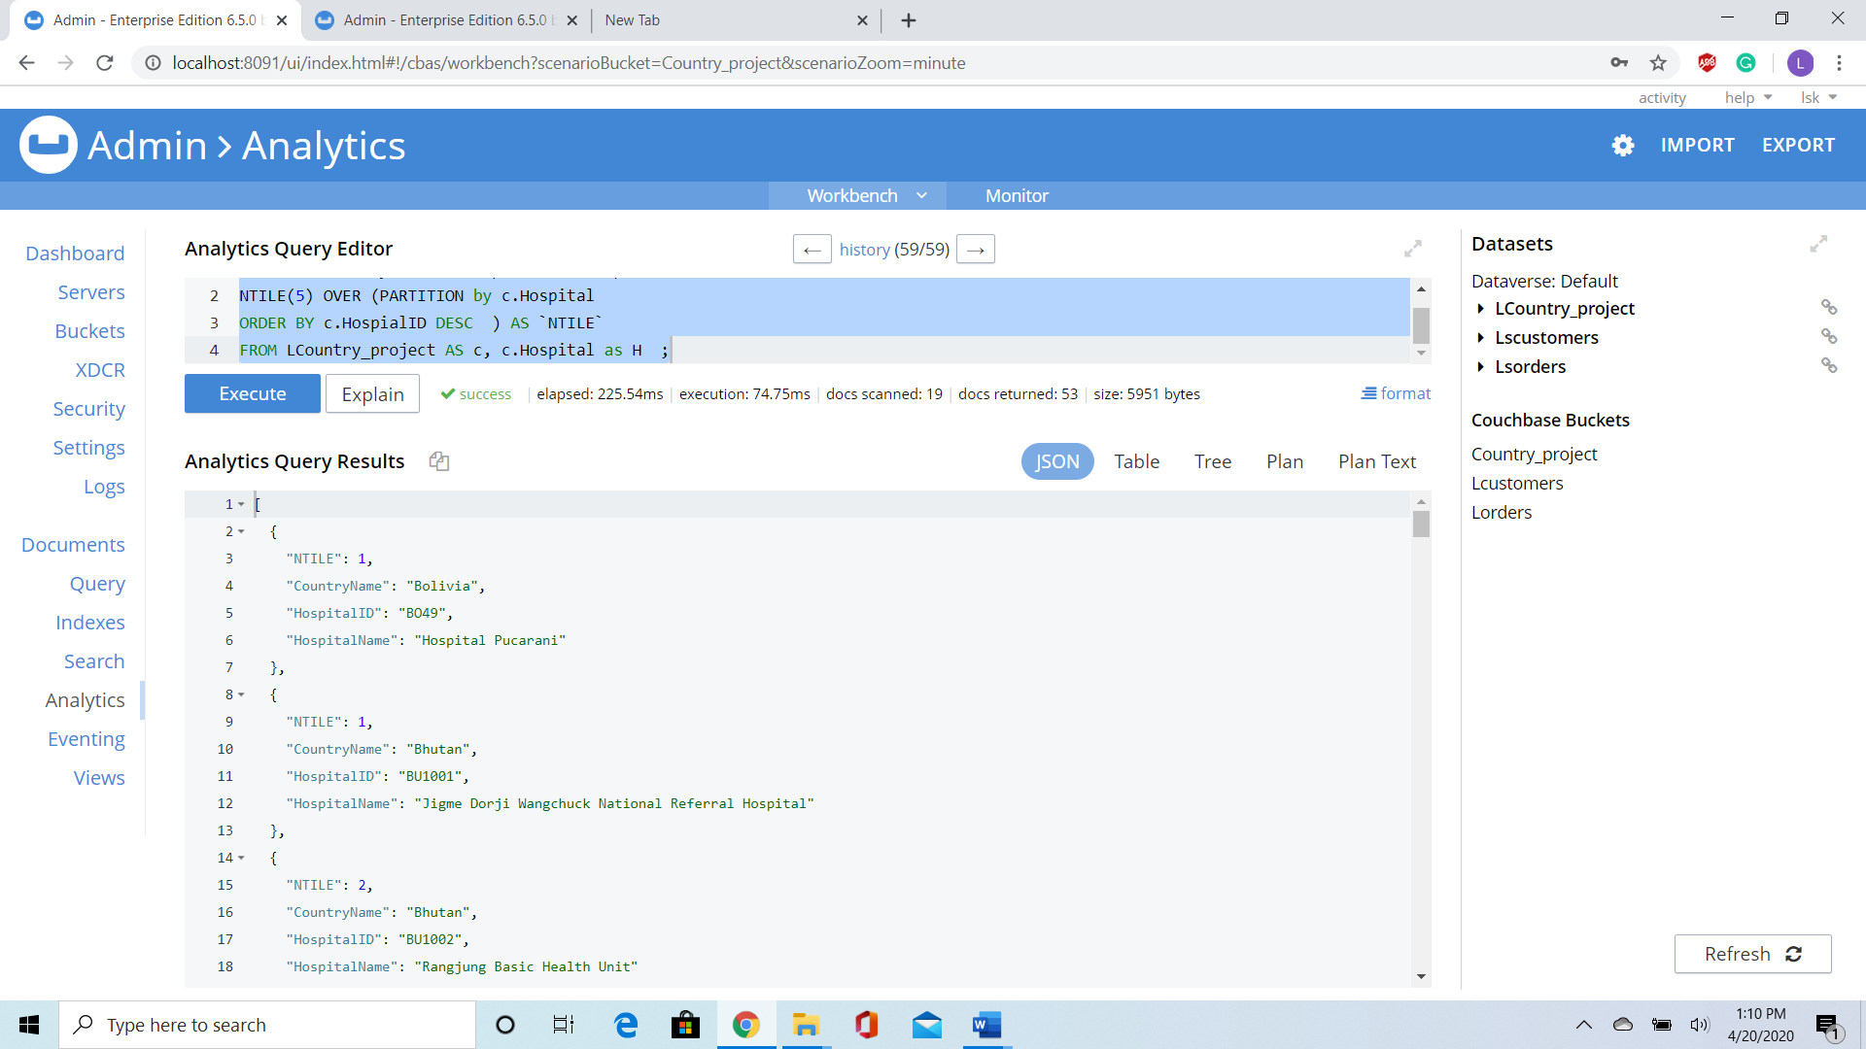

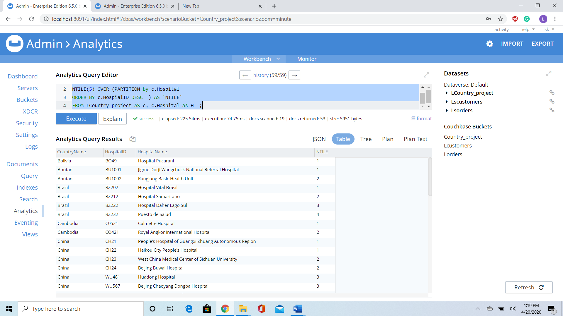

## DATA VISUALIZATION

We have created visualization on top of our database using Tableau to make sense of our data which answers many questions of the users

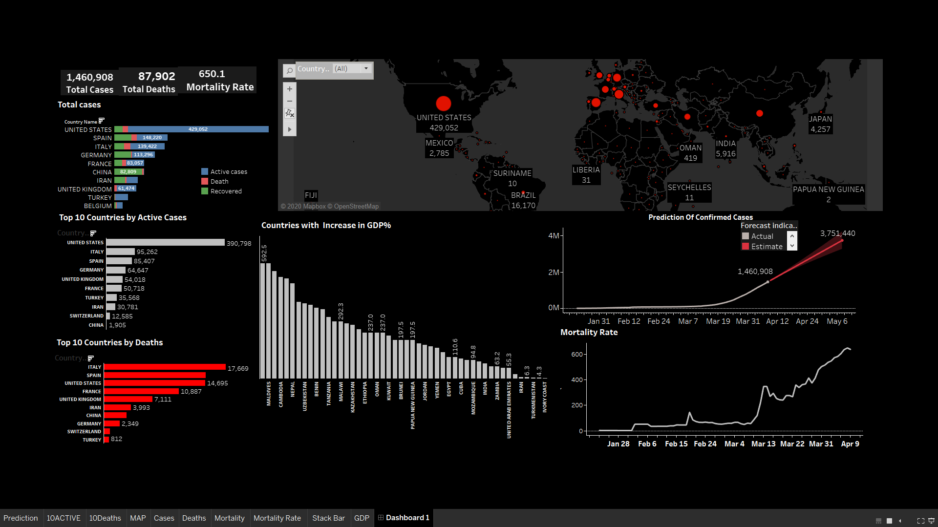

Having a look at our dashboard one can analyze

* The increasing count of Covid19 cases weekly.
* How the GDP of few countries have been affected by coronavirus.
* Total cases by country
* Total cases globally.
* Active cases and death and recovered by country.
* Estimated rise in count of coronavirus in future.
* Mortality percentage globally

We have also added the interactivity filter using which an audience can select the country of their interest.

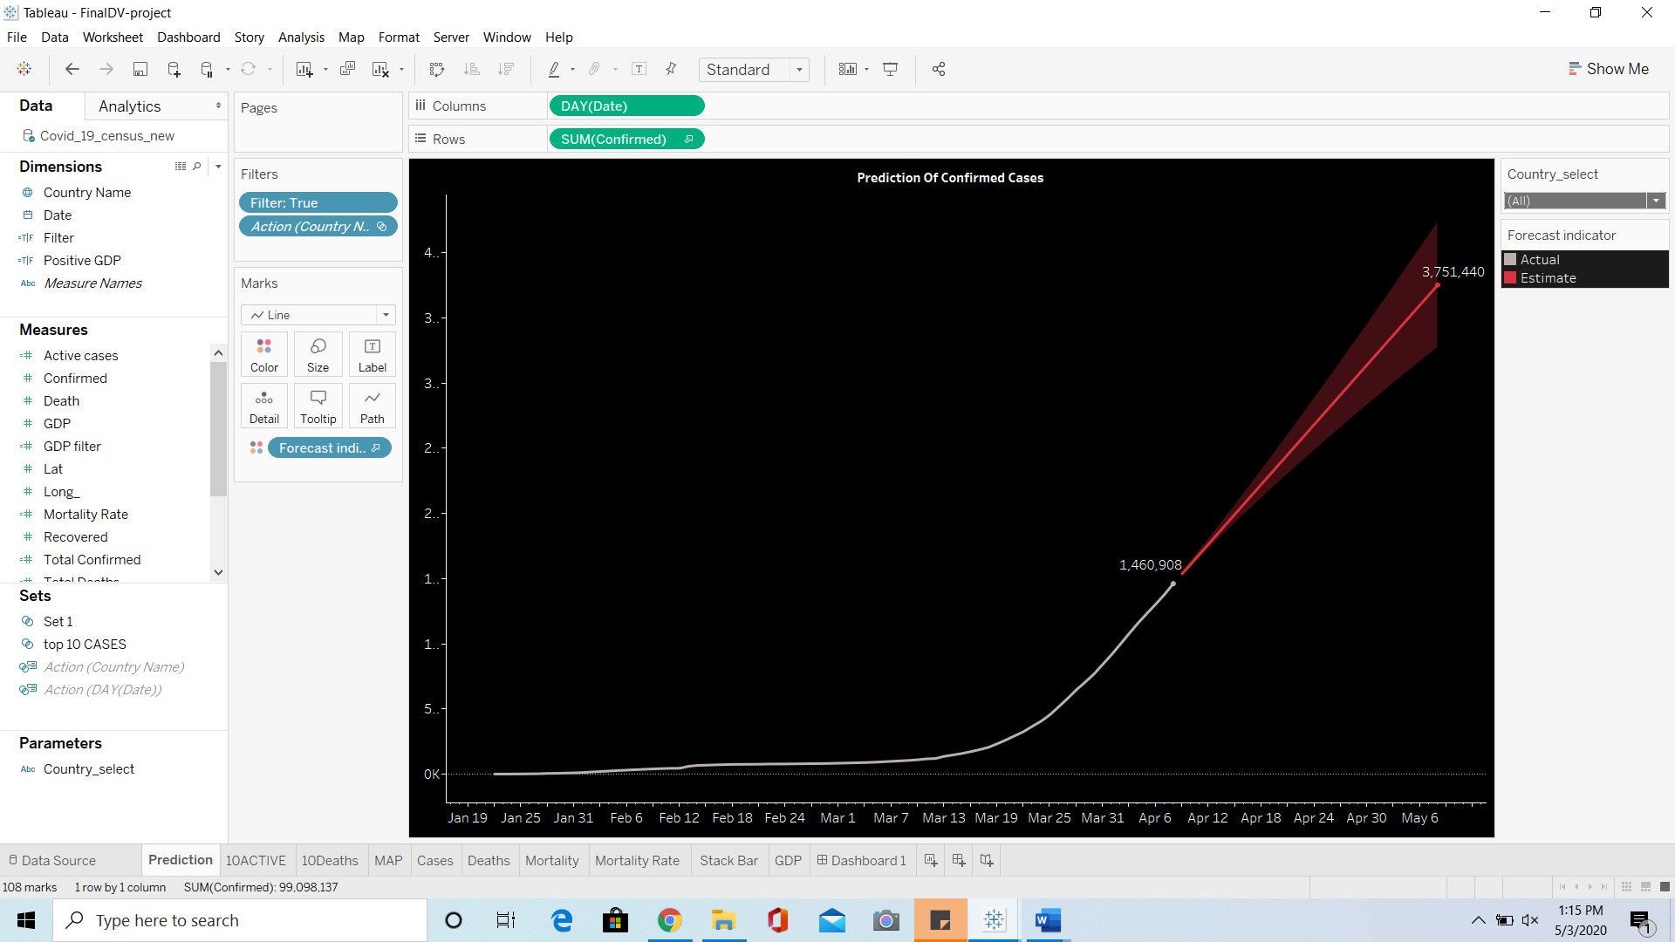

A Visualization representing cases of corona virus for each day, along with Prediction of Corona

Virus using Tableau Prediction Algorithm with a parameter controlling for each Country.

# PART-5

## Conclusion

Our database enables people to understand the decisions, scientists to scrutinize and improve them, and countries to support each other by answering most of the question related to Covid19.

With the help of this project we can help every single person who is been affected by this pandemic Corona Virus. Due to an exponential increase in the number of cases in just a few months. So that we have enough data to analyze the data and perform necessary queries to get relevant data that could help doctors to be prepared with the hospital beds and medicines to look after patients we have used storage procedures to find the number of patients for a given time interval in each country and what are the repercussions on Country's GDP, which countries still have positive GDP increase Compare to time before Corona Virus.

We have taken data on hospitals like which country it belongs, how many patients it has and performed window functions to rank the countries based on the number of hospitals each of them has.

We have used Tableau to present data and queries that we used in this project.We have also predicted the number of people with coronavirus which can be filtered by each country and give the desired breakdown of countries, states, and year, days.

We are planning to develop an app that can update data daily and work on live data, to implement machine learning techniques that can be deployed to predict the expected number of potential victims in these areas. Adding some more information like tracing devices and registration number of a registered patient we can achieve Bluetooth contact tracing on coronavirus which can be used by doctors and researcher to find necessary solutions with this pandemic if it continues

# PART-6

## FUTURE WORK

1. We can build an app which uses our Covid19 database to view the number of affected people and death globally
2. Based on our data machine learning techniques can be deployed to predict the expected number of potential victims in these areas.
3. Adding some more information like tracing devices and registration number of a registered patient we can achieve Bluetooth contact tracing
4. We can build visualization of our data and give desired breakdown of countries, states and year, days

# REFERENCES

1. DATA RECORDS

The database has been made available publicly as of 20th January 2020. It can be downloaded freely from (<https://github.com/beoutbreakprepared/nCoV2019>) and directly from a Google Drive Link: [https://docs.google.com/spreadsheets/d/1itaohdPiAeniCXNlntNztZ_oRvjh0HsGuJXUJWET008/ edit#gid=0](https://docs.google.com/spreadsheets/d/1itaohdPiAeniCXNlntNztZ_oRvjh0HsGuJXUJWET008/%20edit%23gid=0) in .csv format and be imported it into a variety of software programs

(ref: <https://github.com/beoutbreakprepared/nCoV2019/>)

1. <https://gisanddata.maps.arcgis.com/apps/opsdashboard/index.html#/bda7594740fd40299423467b48e9ecf6>
2. <https://tradingeconomics.com/forecast/gdp-annual-growth-rate>